**Week 5 – Final Project**

Ben Merritt

The University of Arizona Global Campus

CST 310: Software Development

Instructor: Joseph Rangitsch

May 22, 2023

**The Employee Portal Website – Final Project**

This paper discusses the steps to create working employee portal website that retrieves employee information from the database. The document includes screenshots of the Employee Portal Website pages and with source code. An employee portal assists employees and managers in ensuring their data is correct in the system.

**Screenshots of the Employee portal website page layout:**

**Table of Figures**

Figure 1. Website not connected to database. 4

Figure 2. Created Database CST310_ben with six tables by Importing SQL file. 5

Figure 3. Database is now connected to the website. This is the index.php page or home page. 6

Figure 4. About Us Page. about.php and is linked to the About Us tab on the website bar. 6

Figure 5. Contact Us page linked to the Contact Us tab on the website bar. 7

Figure 6. Login Tab clicked brings up Login screen. 7

Figure 7. Registration tab brings up registration page. 8

Figure 8. Logging into admin@admin.com Password is Admin created during SQL Import. 8

Figure 9. Profile page profile.php and model.php format page. 9

Figure 10. Home Tab shows Logged in username and First name in welcome. 9

Figure 11. Logout Tab logs out to Login.php then clicked registration Tab. 10

Figure 12. jane@example.com info entered Password 123456. Md5 password encryption. 10

Figure 13. After three seconds after registered automatically directed to Login screen. 11

Figure 14. Database shows Admin user_id 1 & role 3 and Jane user_id 2 & role 1 12

Figure 15. User_role 3 is Administrator, 1 is Employee and 2 is Manager. 13

Figure 16. Login Jane 14

Figure 17. Janes Profile page is displayed 14

Figure 18. Home Tab shows Jane’s Session logged in Home Page. 15

Figure 19. About Us Page works in logged in or logged out state. 15

Figure 20. Contact Us works in logged in or out state. 16

Figure 21. Entered data into Contact Us Form and Submitted. 16

Figure 22. Contact Us Data received in contact_messages table in database. 17

Figure 23. Jane is an employee and has access to employee Information. 17

Figure 24. Jane can Upload picture files to a folder on the xampp server called uploads. 18

Figure 25. Four files were chosen to load all at once. Multifile feature. 18

Figure 26. Files were Uploaded to uploads folder on xampp server. 19

Figure 27. employee can update limited information. 19

Figure 28. Jane updates password to 654321 and address 20

Figure 29. Jane will be automatically logged out to update data. 20

Figure 30. Jane logs back in with new password 654321 21

Figure 31. Janes data changed. 21

Figure 32. Logged in as Admin in Admin Tab Admin Panel. 22

Figure 33. Janes User Id is 2 and Role is 1 23

Figure 34. Update Jane to a 2 as a manager. 23

Figure 35. Successful. 24

Figure 36. Jane is upgraded to a Manger 24

Figure 37. Database updated in tbluser. 25

Figure 38. Database updated in user_role. 25

Figure 39. Jane logs back in. 26

Figure 40. Jane has access to Manager tabs. 26

Figure 41. User Roles information. 27

Figure 42. More Employees information. 27

Figure 43. Update User Information page. 28

Figure 44. Register John smith. 28

Figure 45. Logged in John. 29

Figure 46. Logged in Jane. John is user 3 role 1 29

Figure 47. Jane sees Johns last name Smith and salary 4000 30

Figure 48. Jane updates Johns Last name Doe and salary to 4500. 30

Figure 49. Jane is successful changing Johns information. 31

Figure 50. Data shows in Manager Employees Page. 31

Figure 51. Admin Login John is user 3 role 1. 32

Figure 52. John is upgraded to Manager. 32

Figure 53. Employee User-Role page shows Updated information. 33

Figure 54. Admin Panel User 3 John entered for Removal. 33

Figure 55. John was removed from database. 34

Figure 56. John is removed from employee role page. 34

Figure 57. John removed from Manager Page. 35

Figure 58. John trys login. 35

Figure 59. Login fails. 36

Figure 60. John is removed from database. 36

Figure 61. John is removed from user_role table also. 37

Figure 62. User role permissions. 37

Figure 63. User Roles. 38

Figure 64. Permissions create, read, update, delete. 38

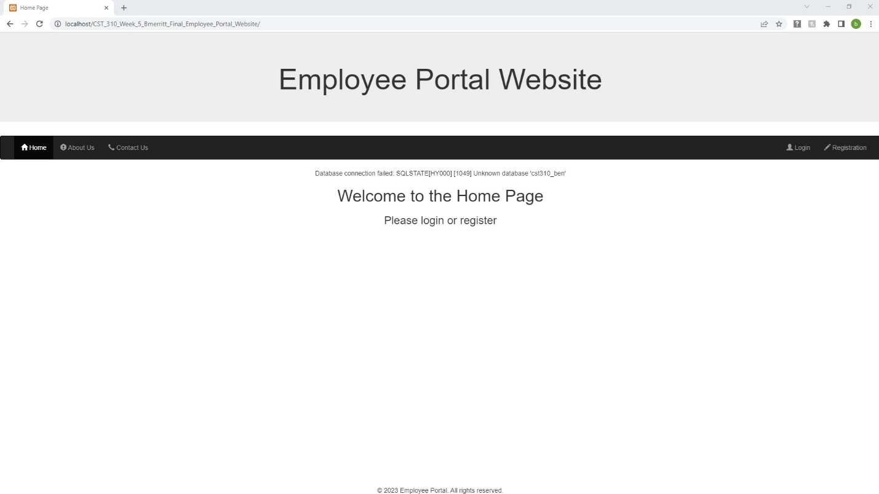

Figure . Website not connected to database.

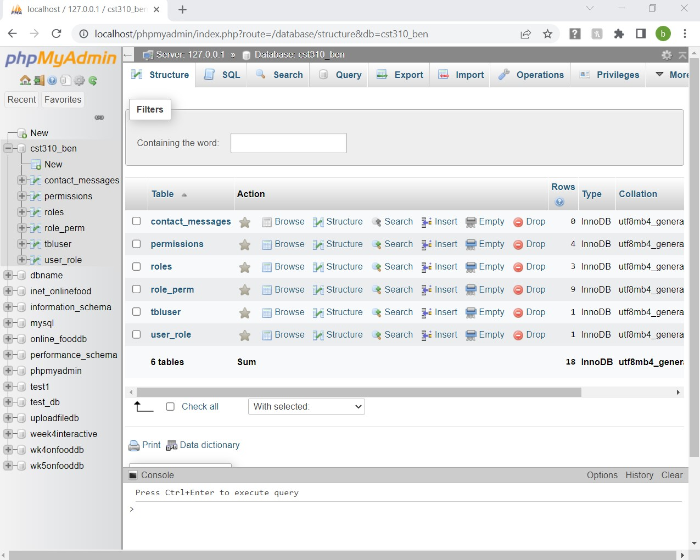

Figure . Created Database CST310_ben with six tables by Importing SQL file.

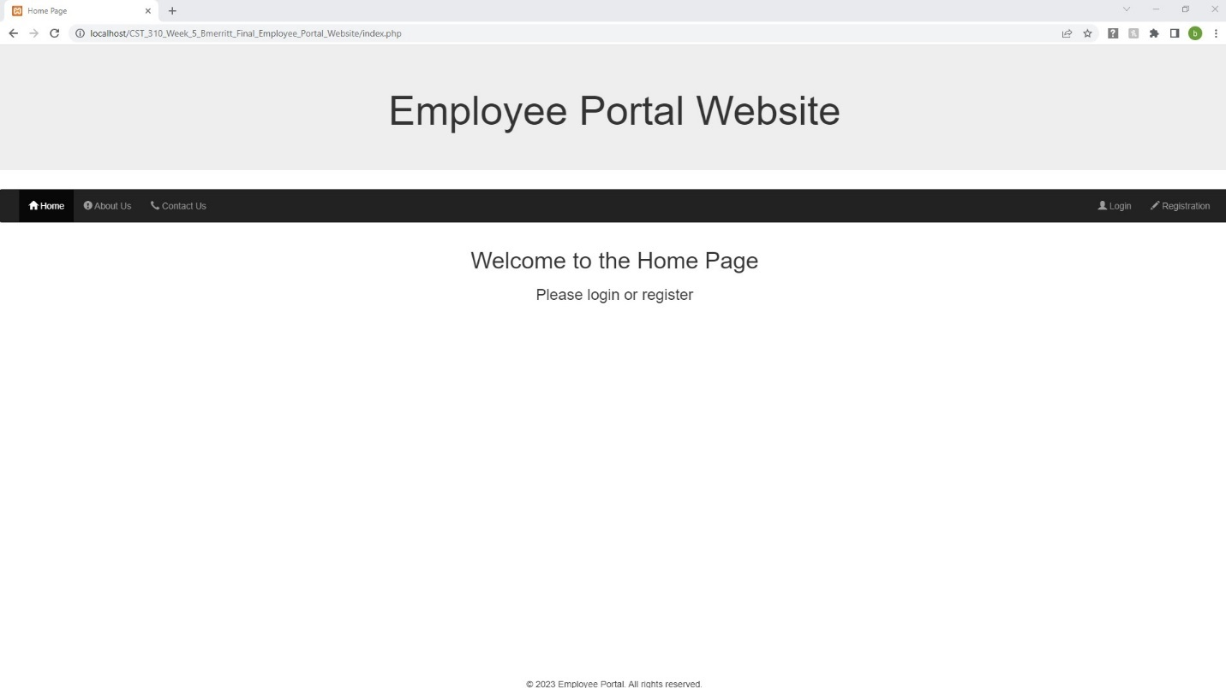

Figure . Database is now connected to the website. This is the index.php page or home page.

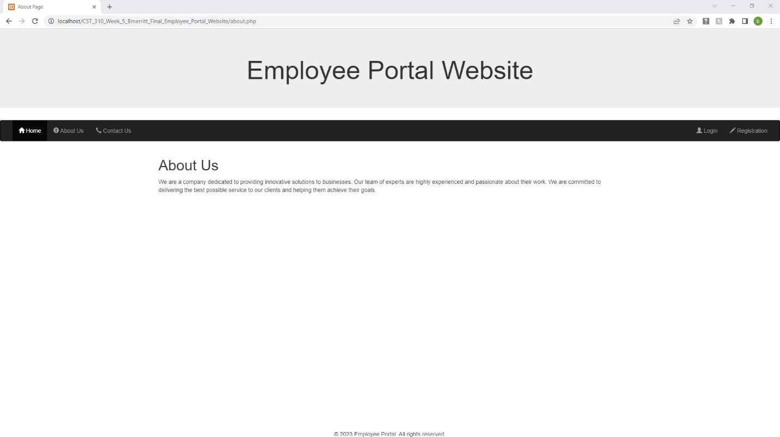

Figure . About Us Page. about.php and is linked to the About Us tab on the website bar.

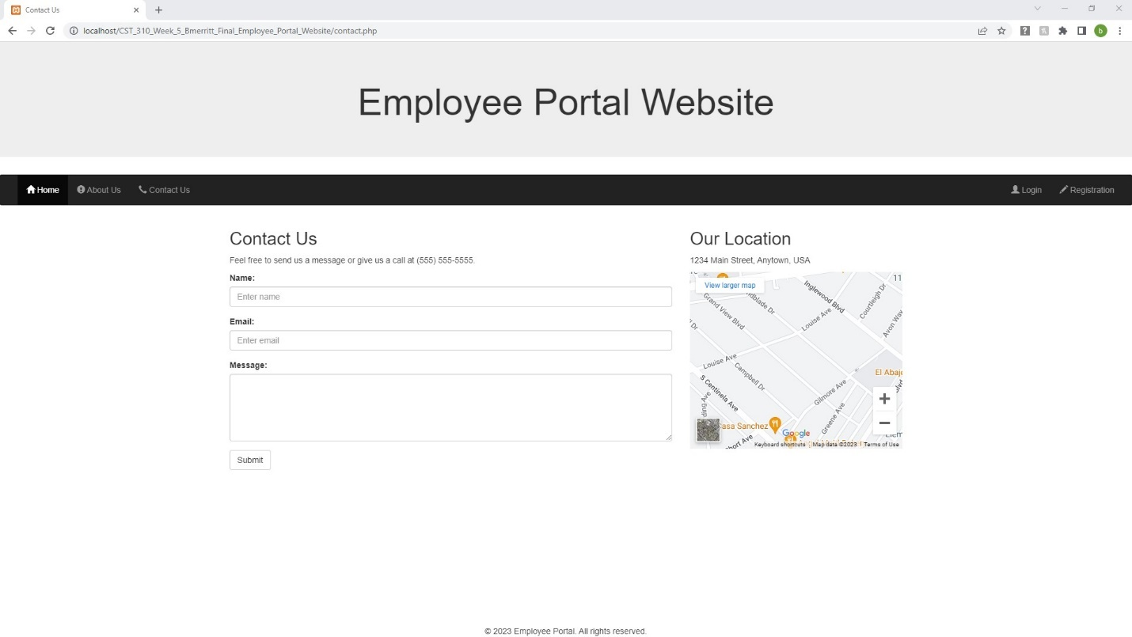

Figure . Contact Us page linked to the Contact Us tab on the website bar.

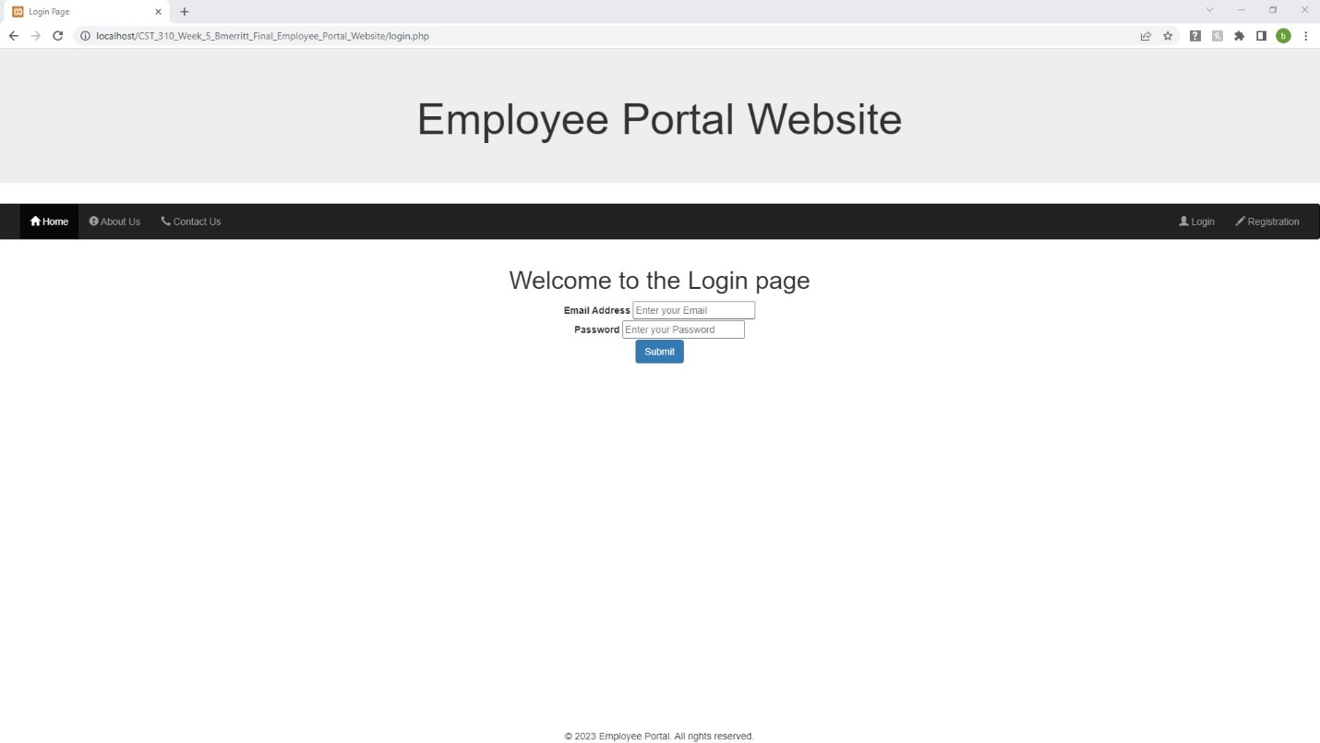

Figure . Login Tab clicked brings up Login screen.

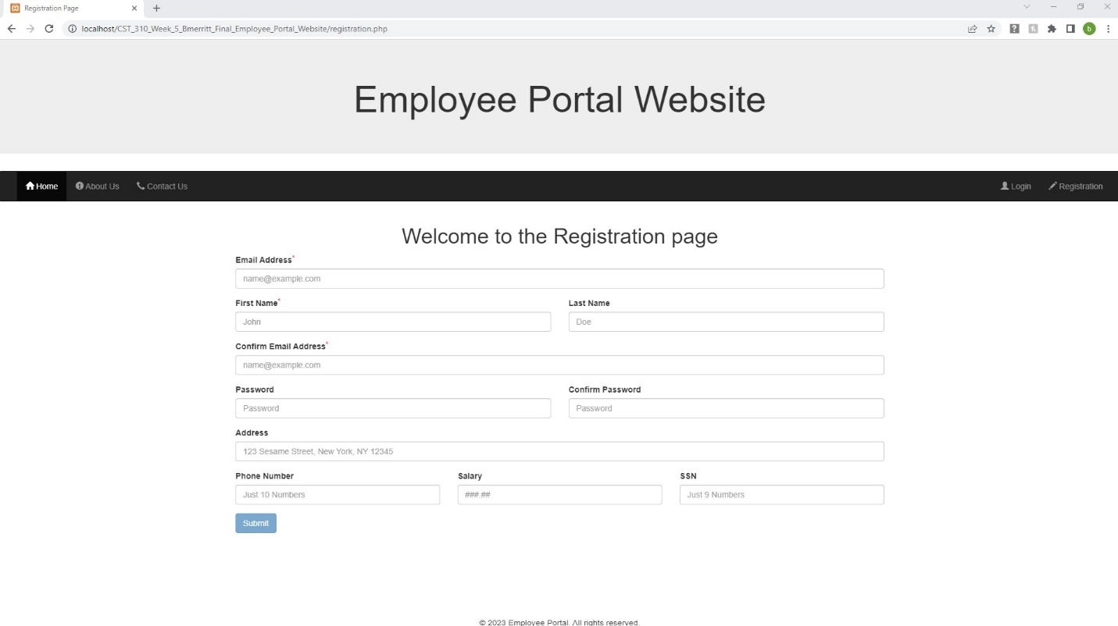

Figure . Registration tab brings up registration page.

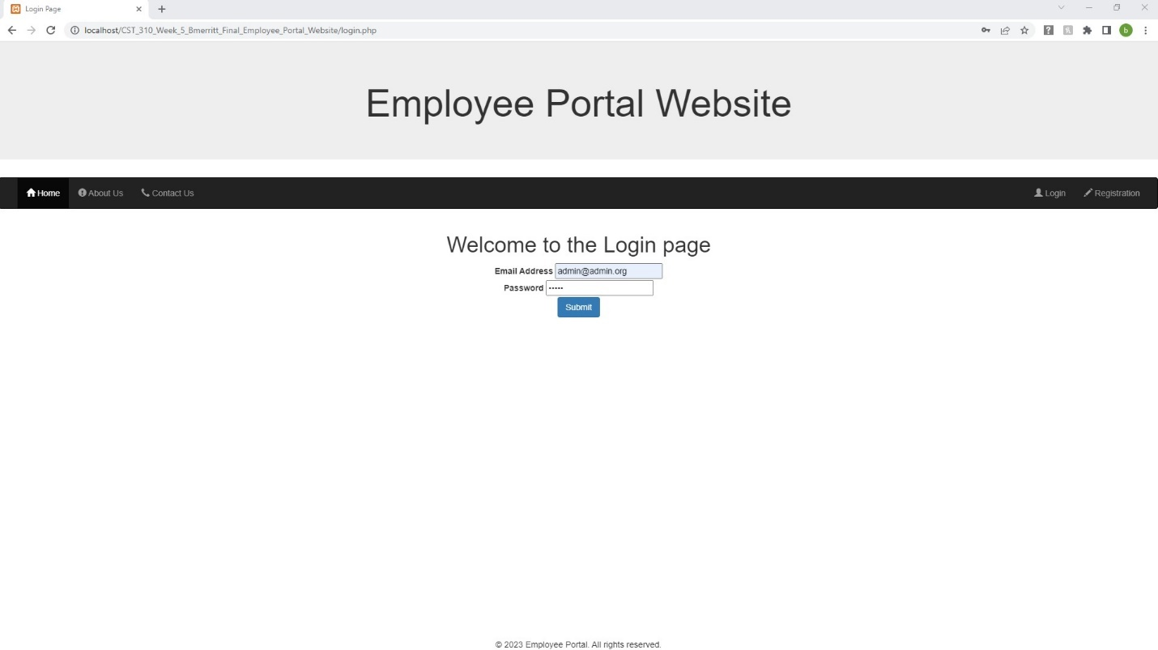

Figure . Logging into [admin@admin.com](mailto:admin@admin.com) Password is Admin created during SQL Import.

Figure . Profile page profile.php and model.php format page.

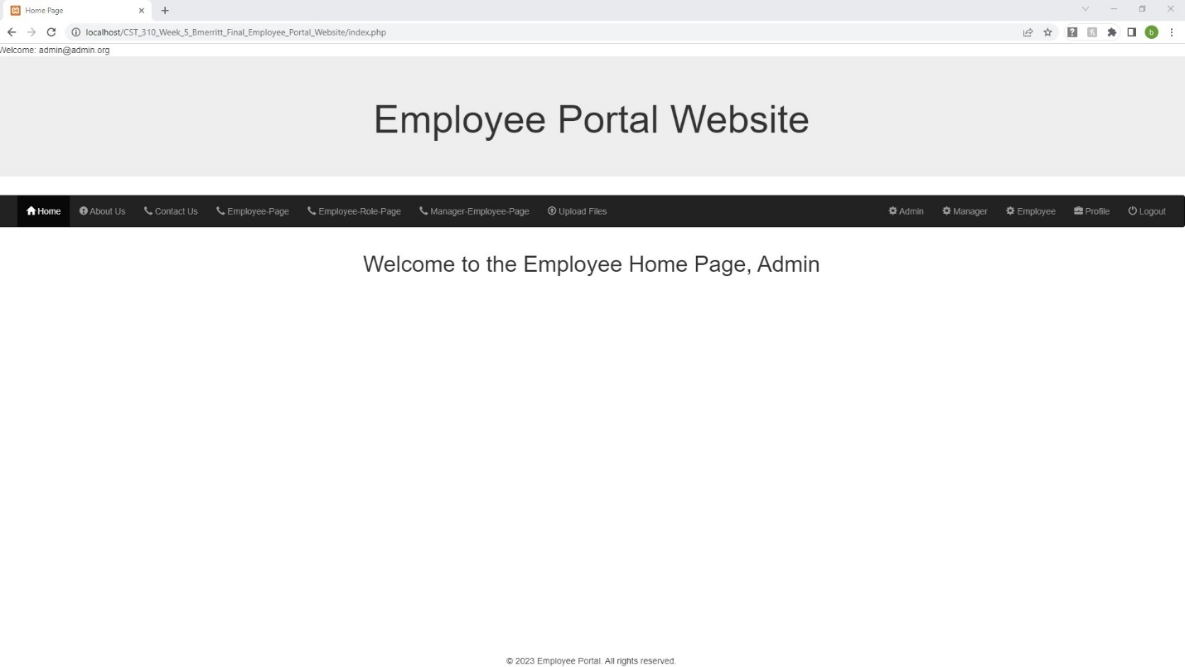

Figure . Home Tab shows Logged in username and First name in welcome.

Figure . Logout Tab logs out to Login.php then clicked registration Tab.

Figure . [jane@example.com](mailto:jane@example.com) info entered Password 123456. Md5 password encryption.

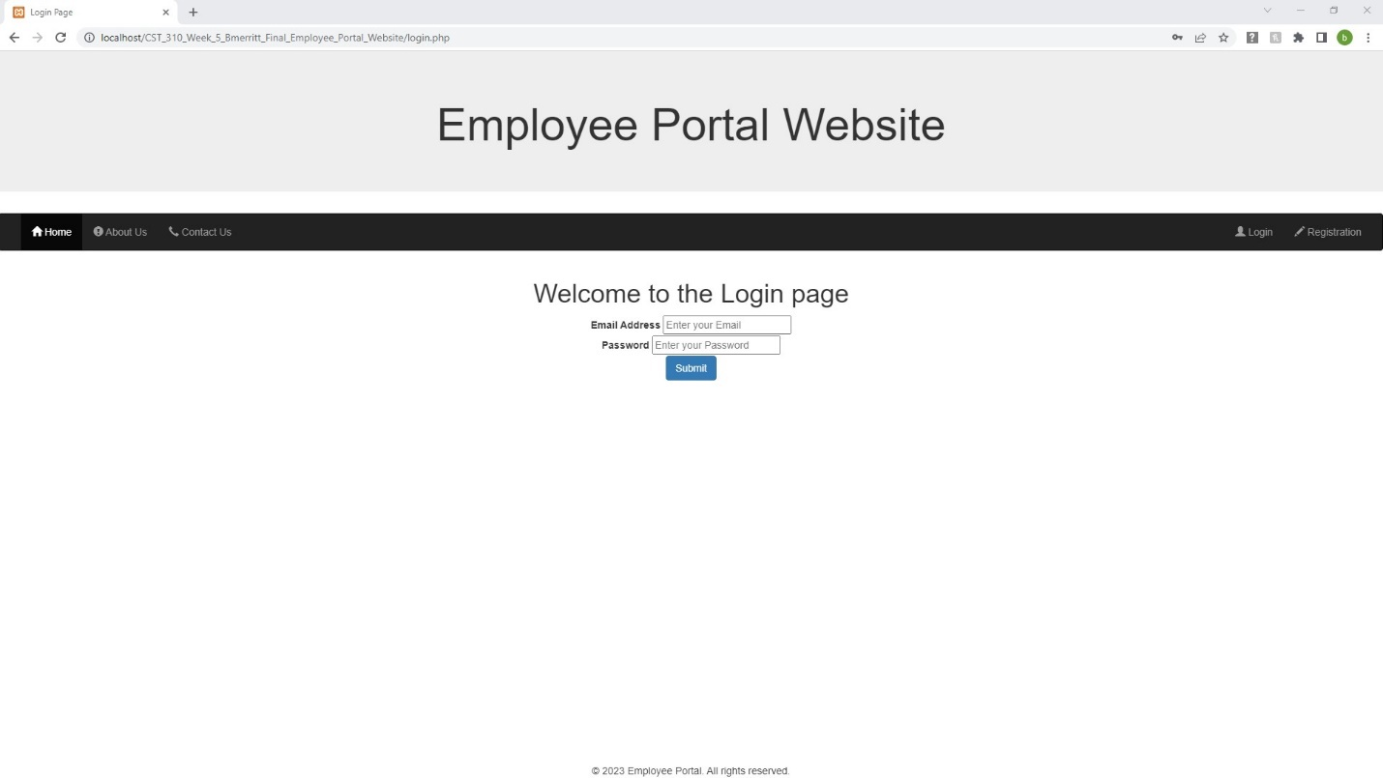

Figure . After three seconds after registered automatically directed to Login screen.

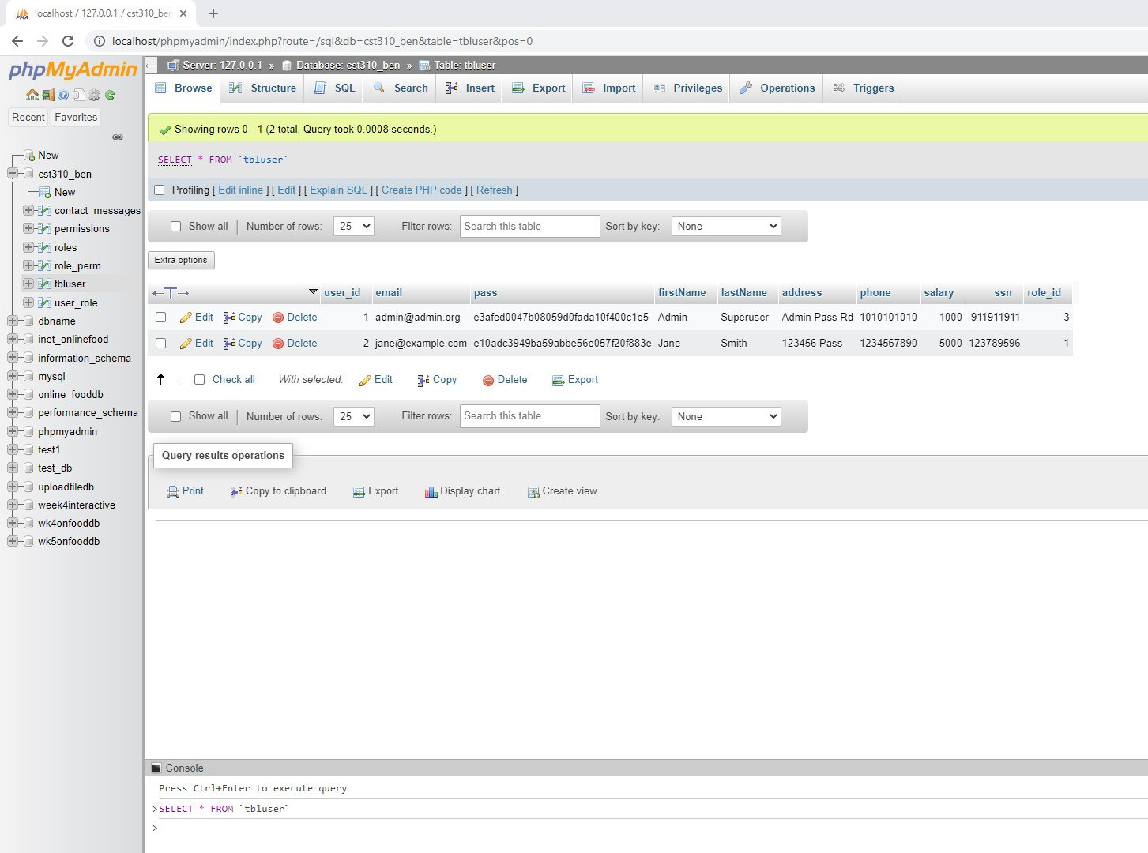

Figure . Database shows Admin user_id 1 & role 3 and Jane user_id 2 & role 1

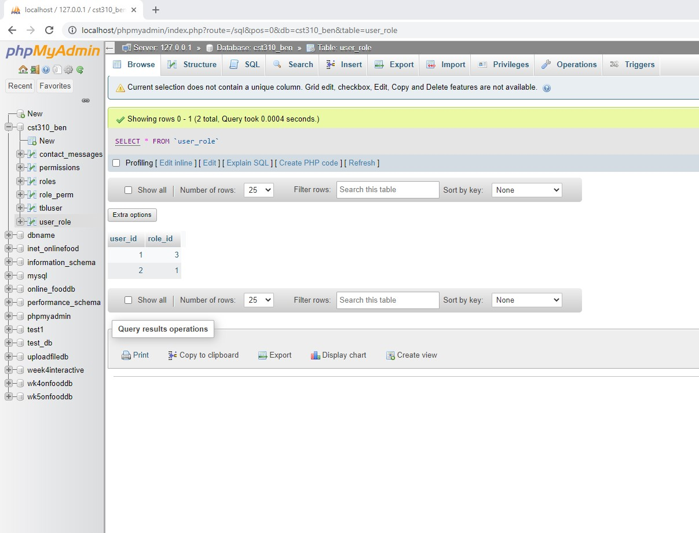

Figure . User_role 3 is Administrator, 1 is Employee and 2 is Manager.

Figure . Login Jane

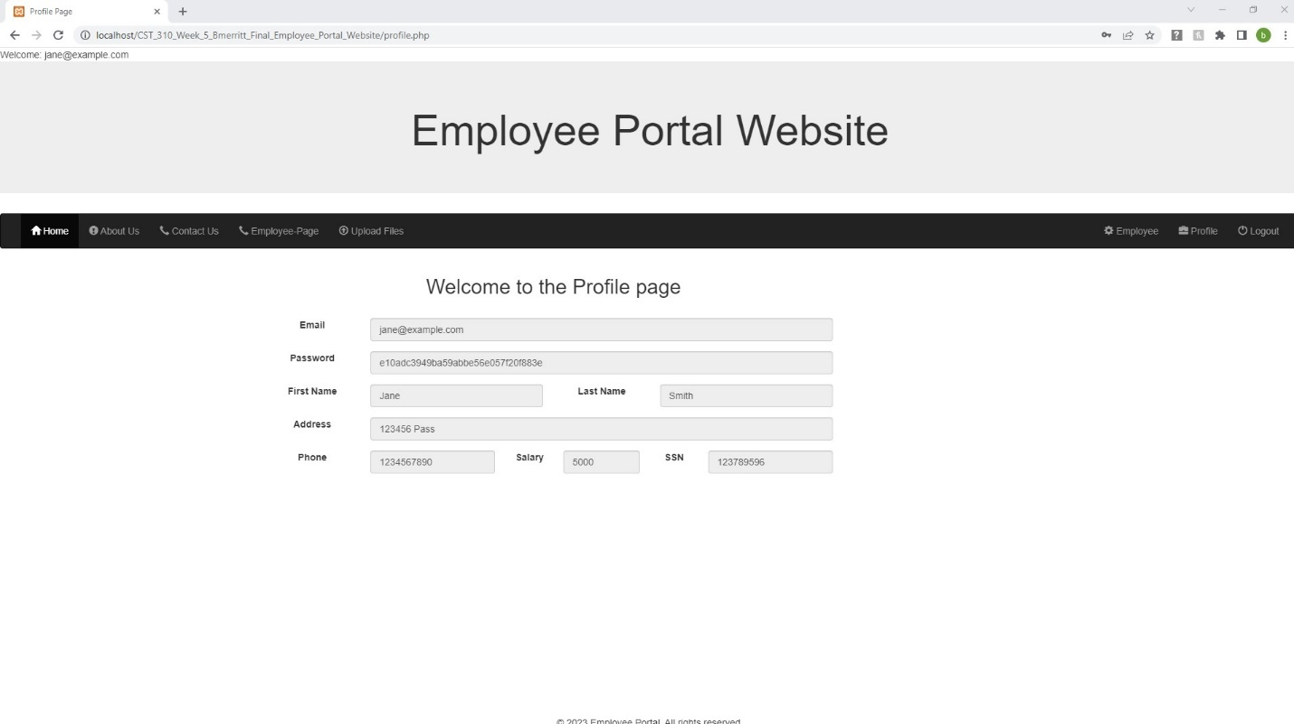

Figure . Janes Profile page is displayed

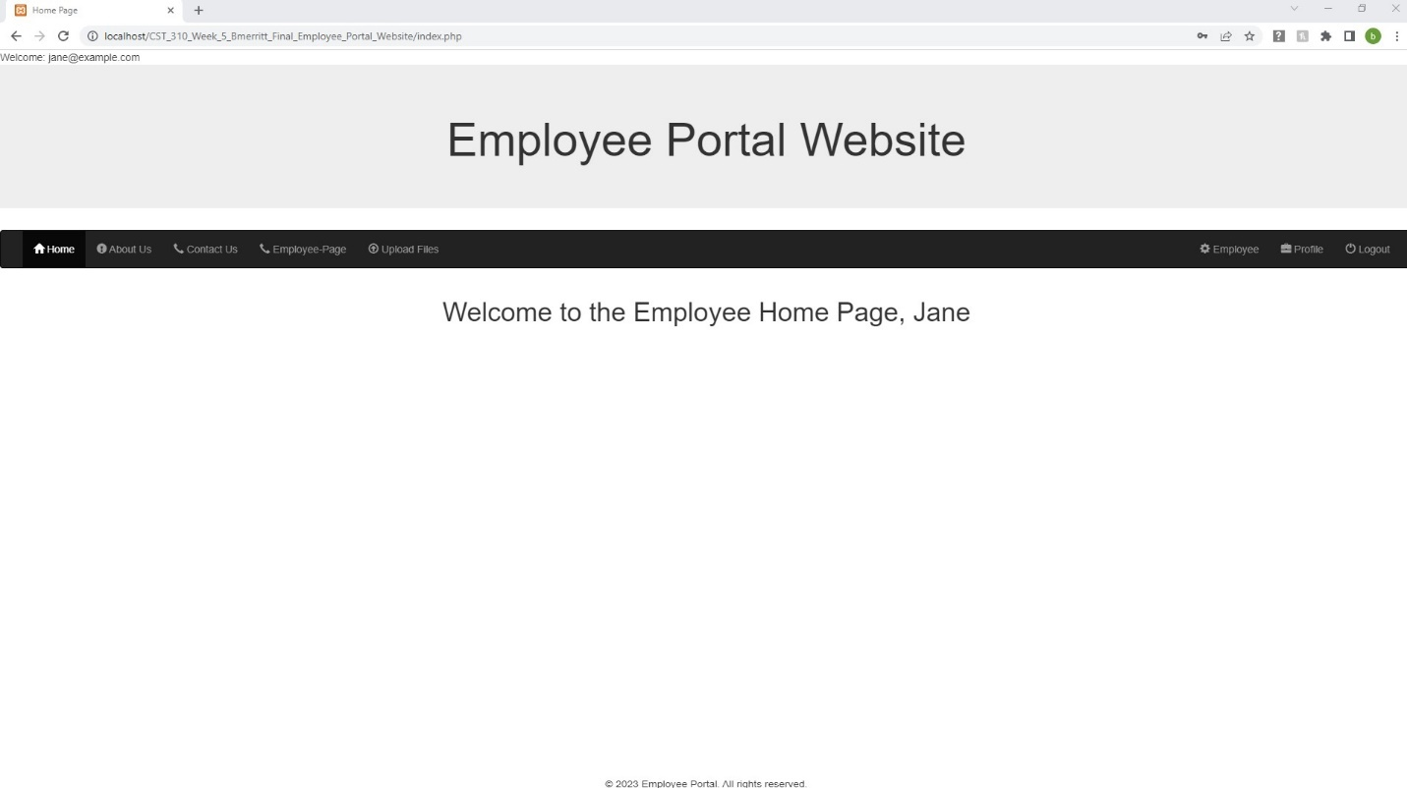

Figure . Home Tab shows Jane’s Session logged in Home Page.

Figure . About Us Page works in logged in or logged out state.

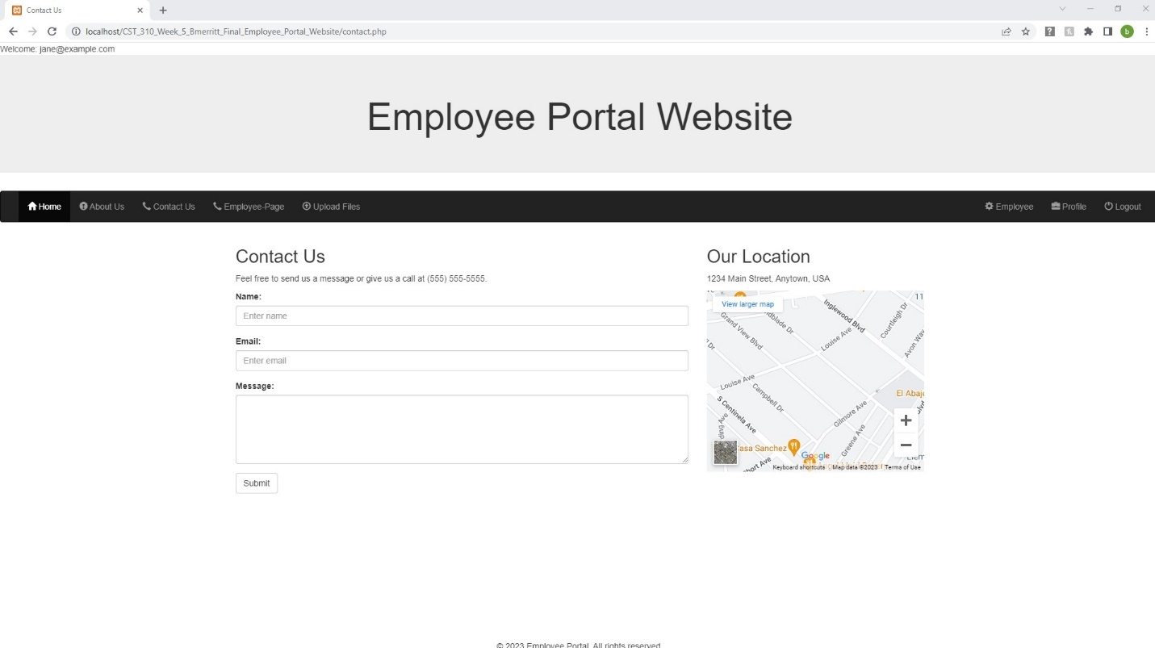

Figure . Contact Us works in logged in or out state.

Figure . Entered data into Contact Us Form and Submitted.

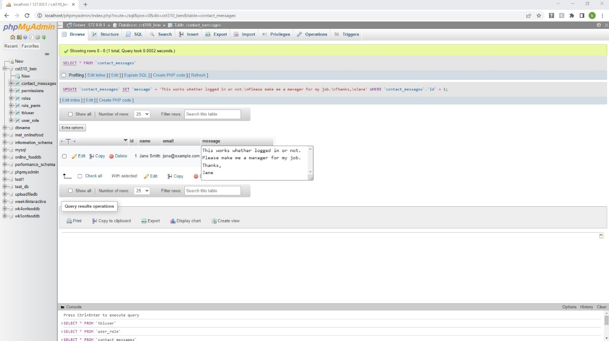

Figure . Contact Us Data received in contact_messages table in database.

Figure . Jane is an employee and has access to employee Information.

Figure . Jane can Upload picture files to a folder on the xampp server called uploads.

Figure . Four files were chosen to load all at once. Multifile feature.

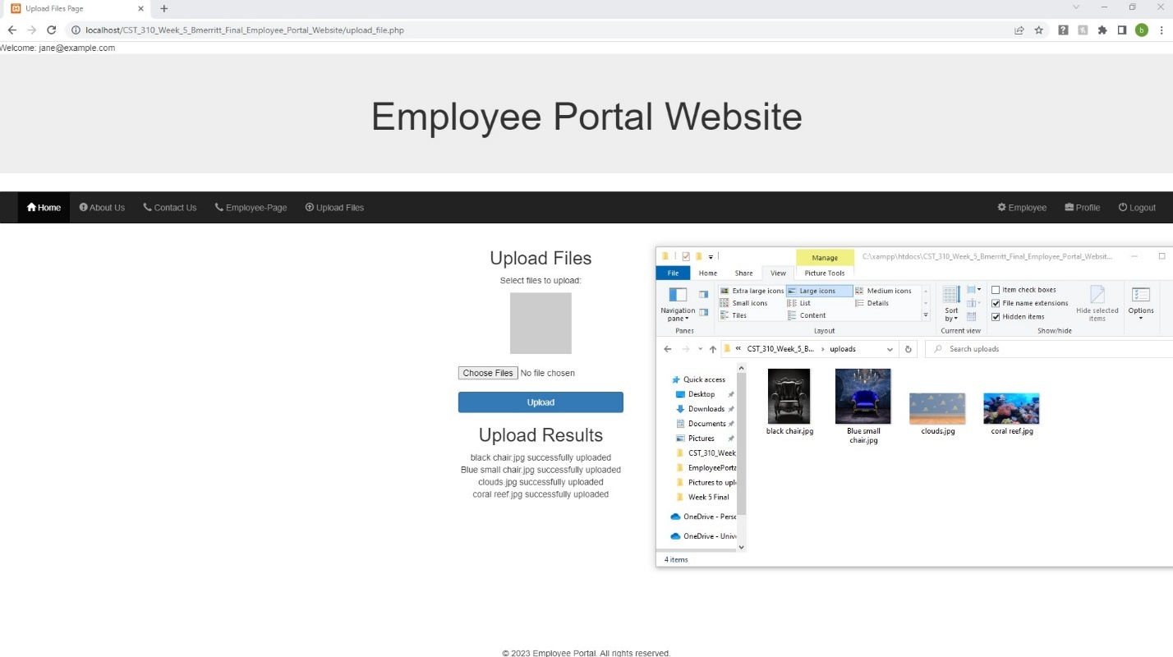

Figure . Files were Uploaded to uploads folder on xampp server.

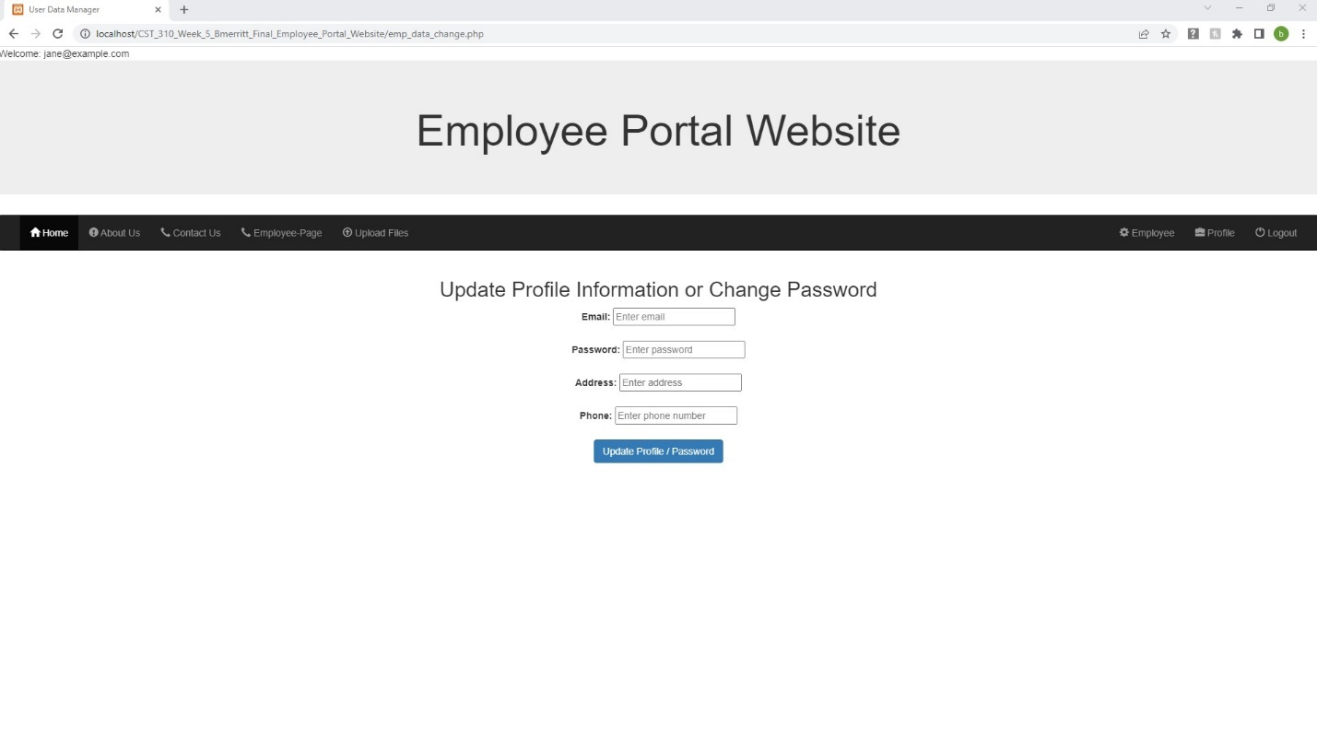

Figure . employee can update limited information.

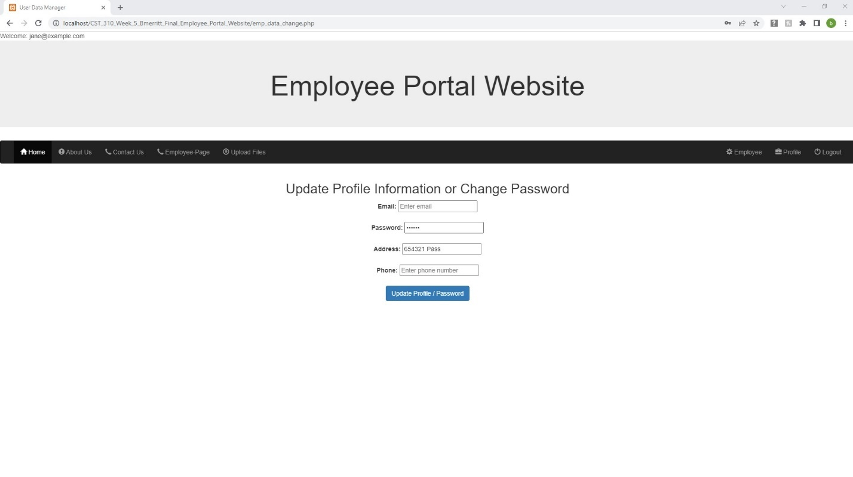

Figure . Jane updates password to 654321 and address

Figure . Jane will be automatically logged out to update data.

Figure . Jane logs back in with new password 654321

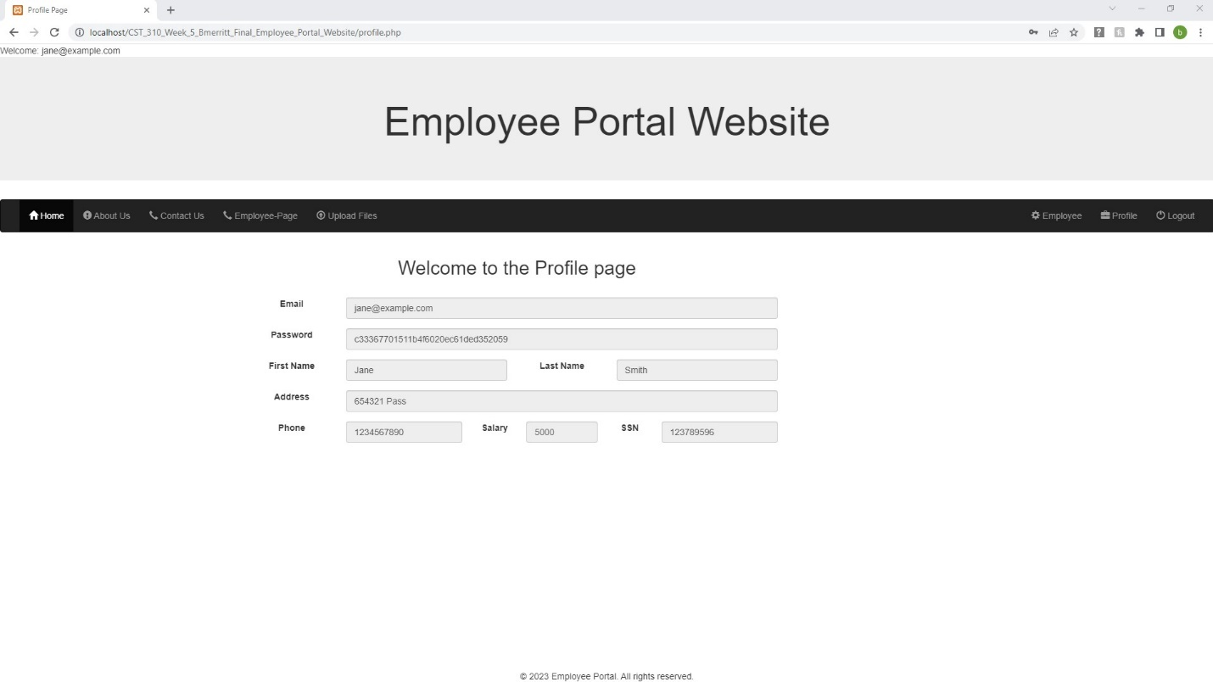

Figure . Janes data changed.

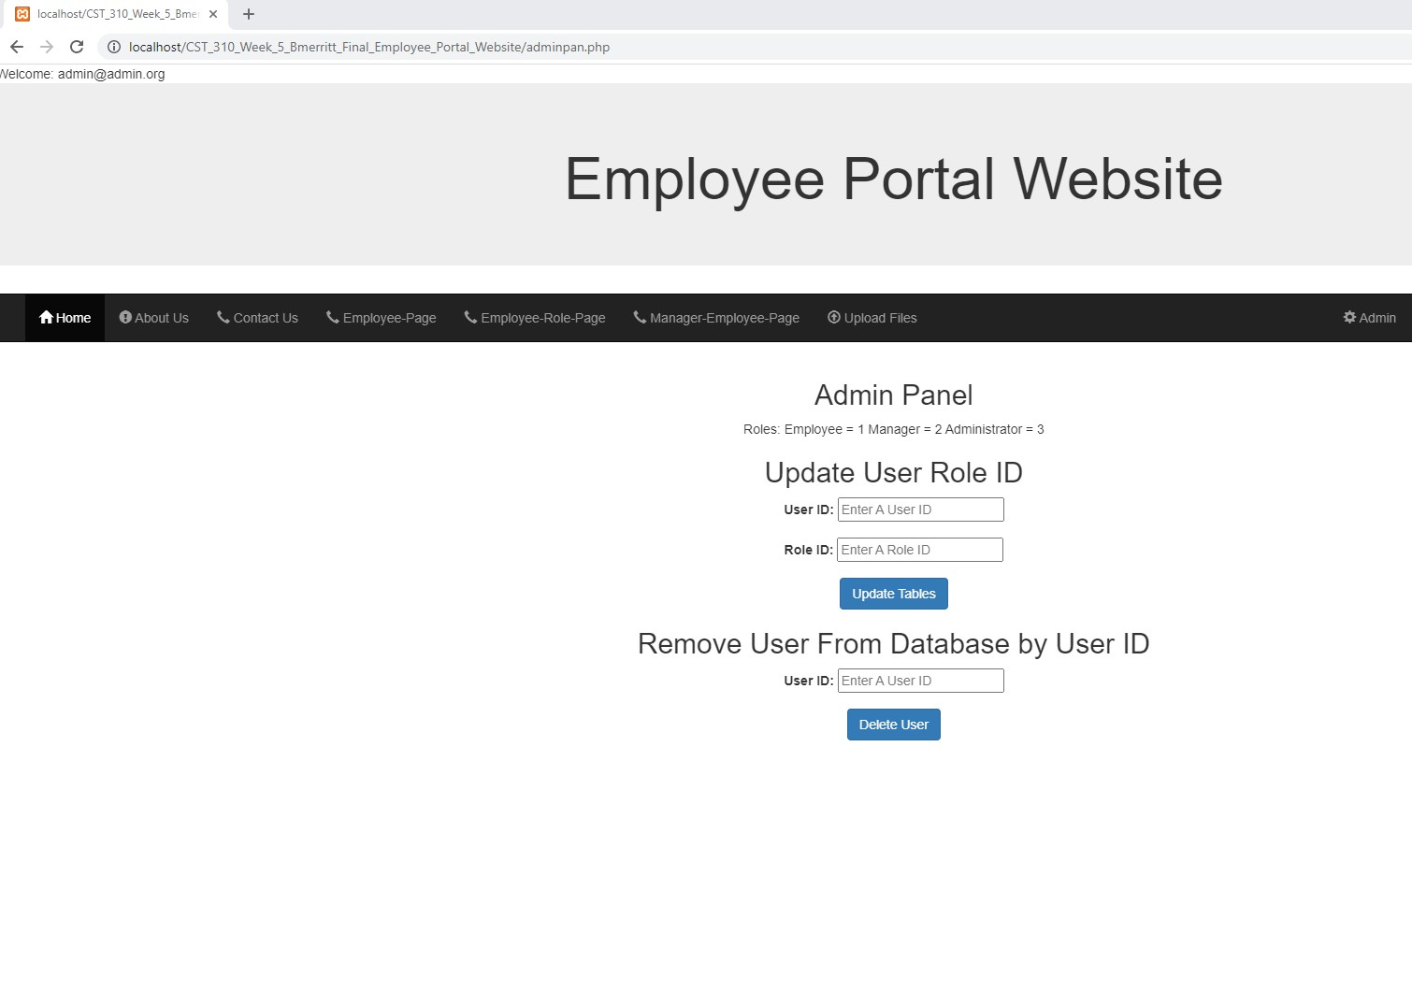

Figure . Logged in as Admin in Admin Tab Admin Panel.

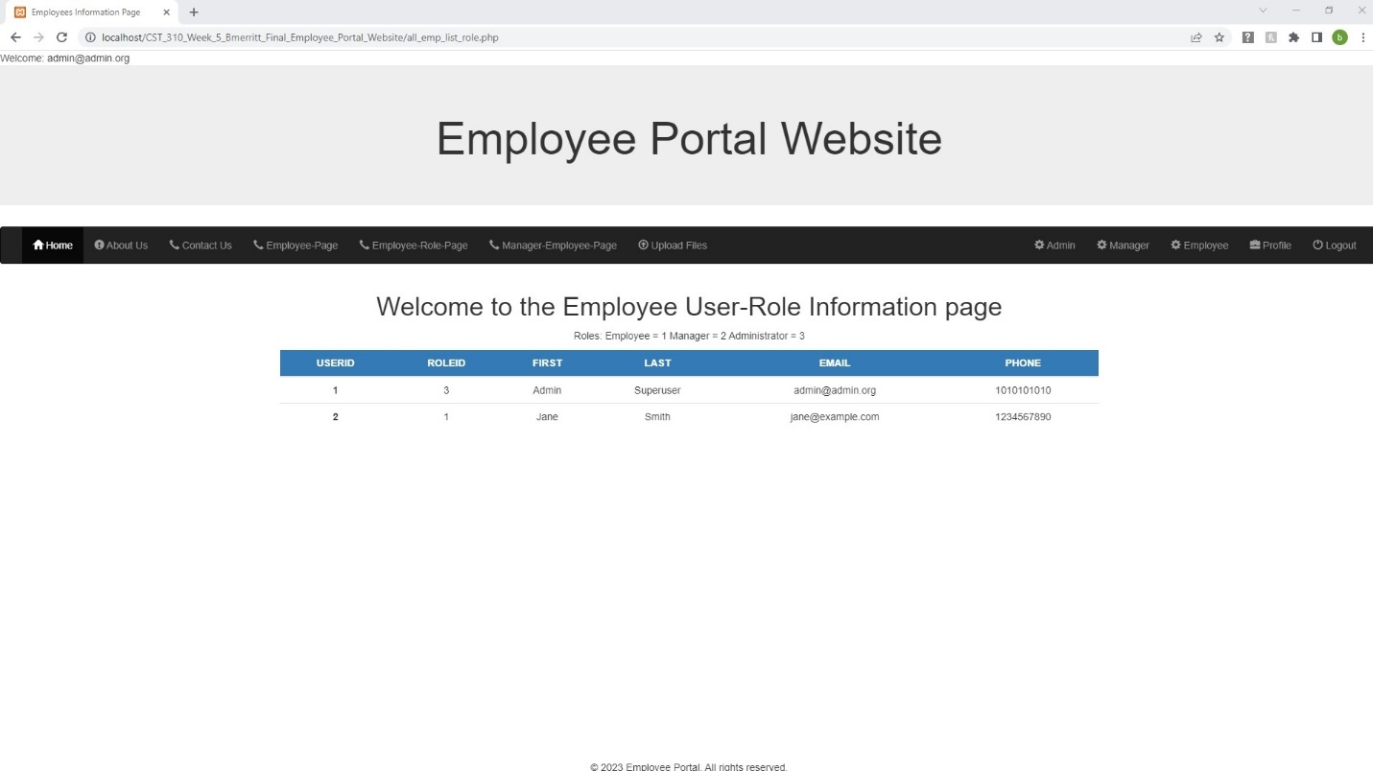

Figure . Janes User Id is 2 and Role is 1

Figure . Update Jane to a 2 as a manager.

Figure . Successful.

Figure . Jane is upgraded to a Manger

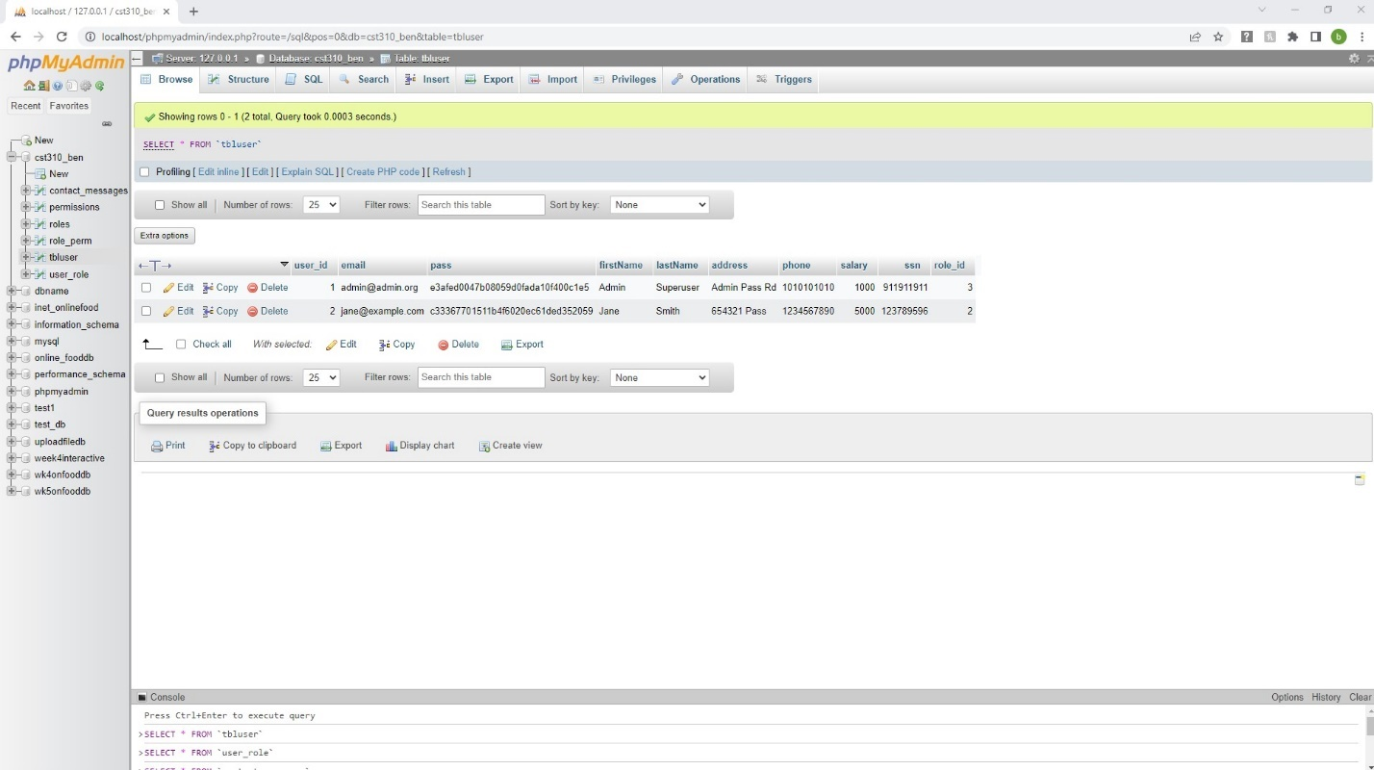

Figure . Database updated in tbluser.

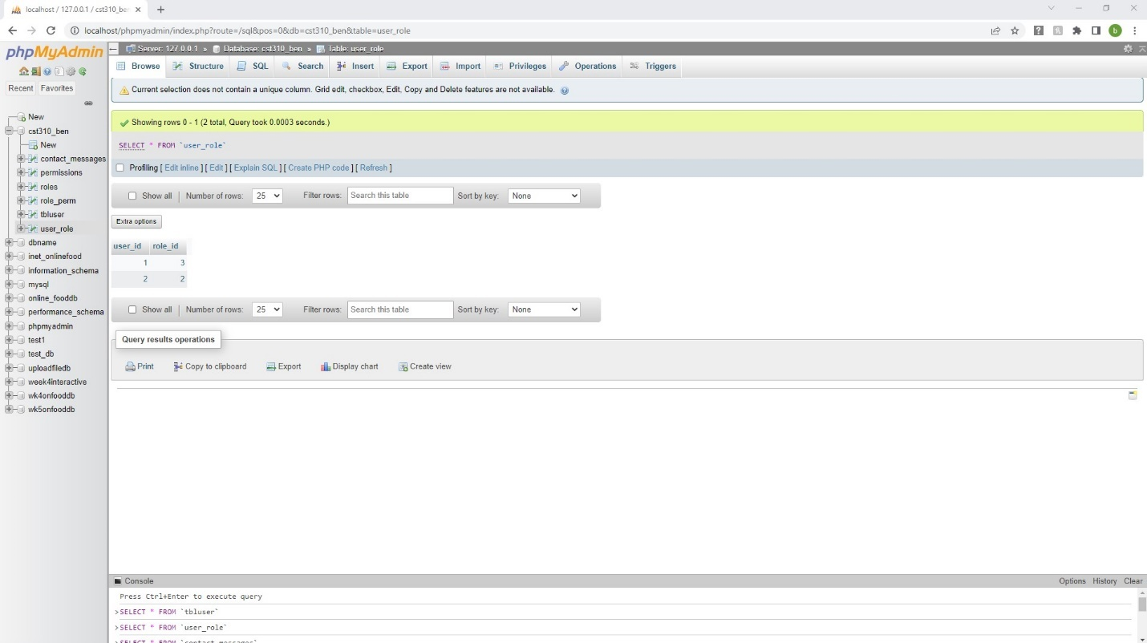

Figure . Database updated in user_role.

Figure . Jane logs back in.

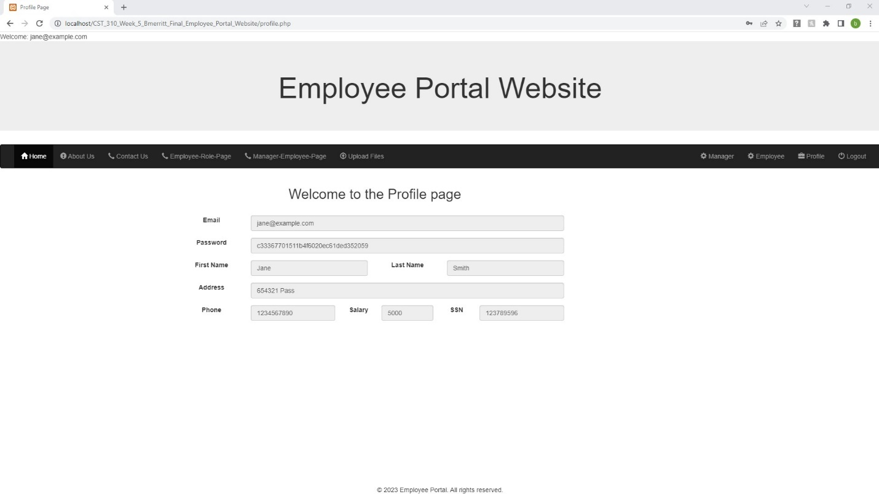

Figure . Jane has access to Manager tabs.

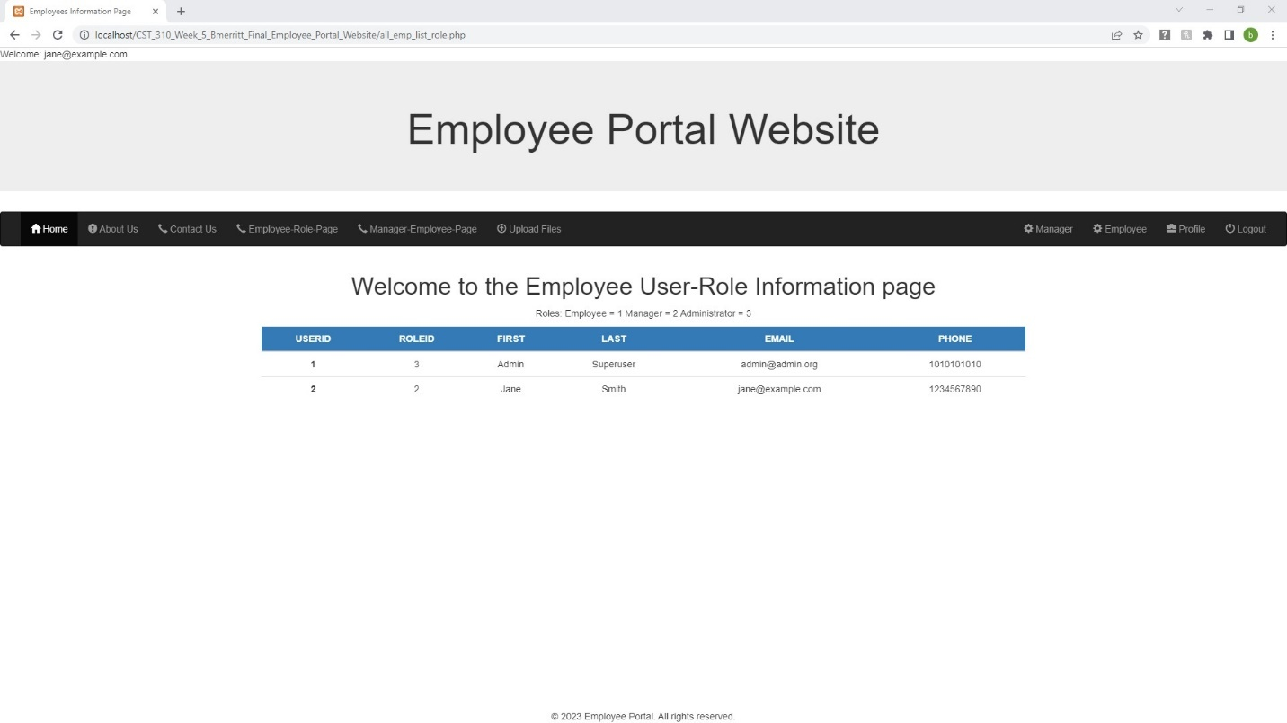

Figure . User Roles information.

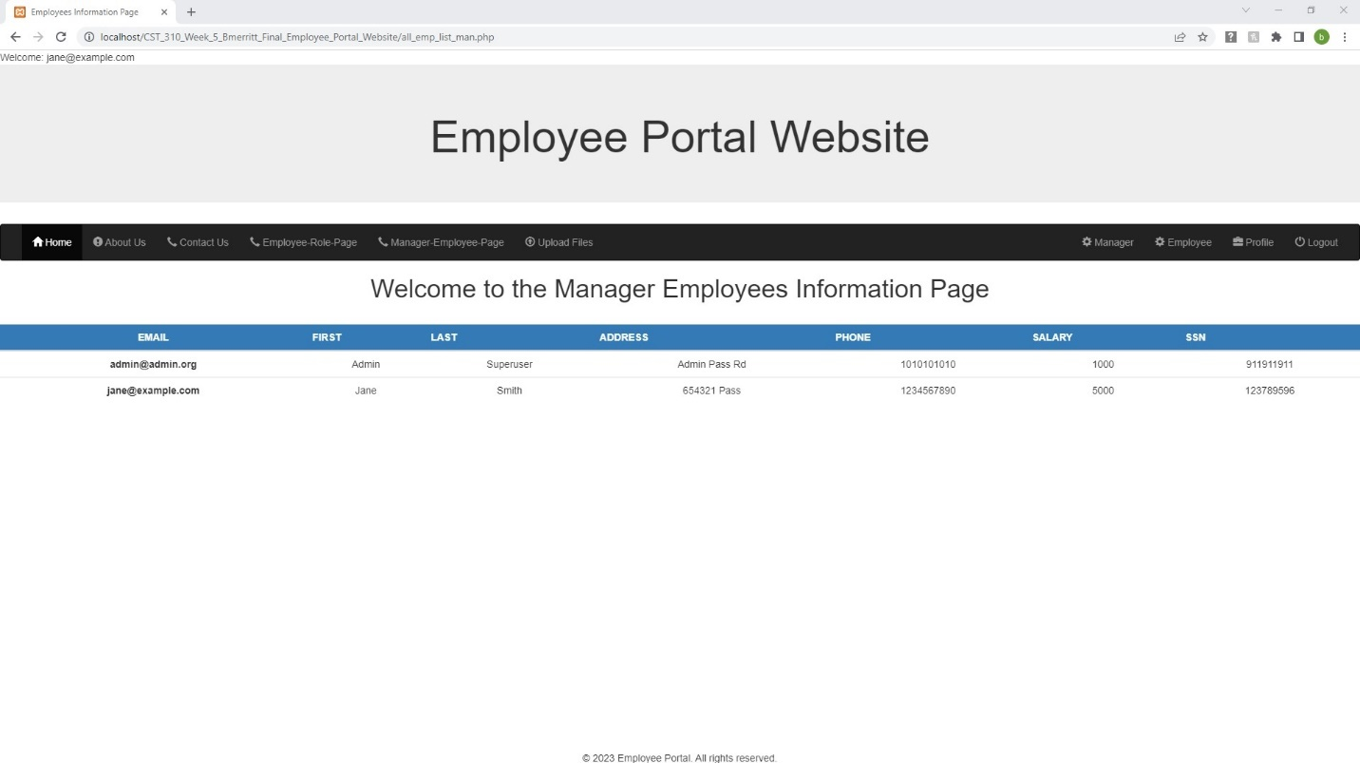

Figure . More Employees information.

Figure . Update User Information page.

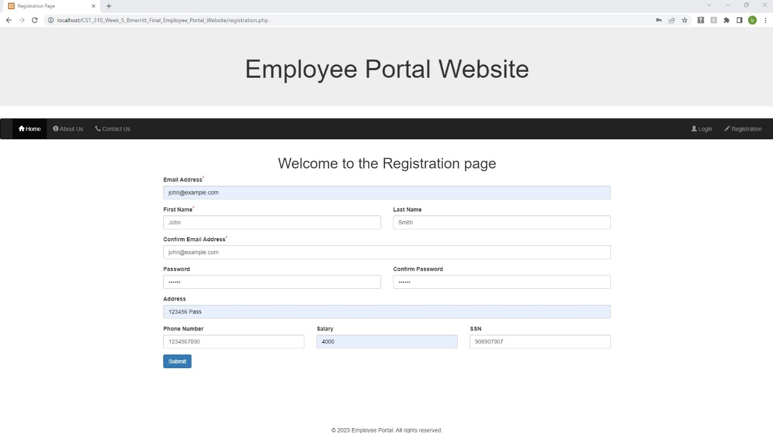

Figure . Register John smith.

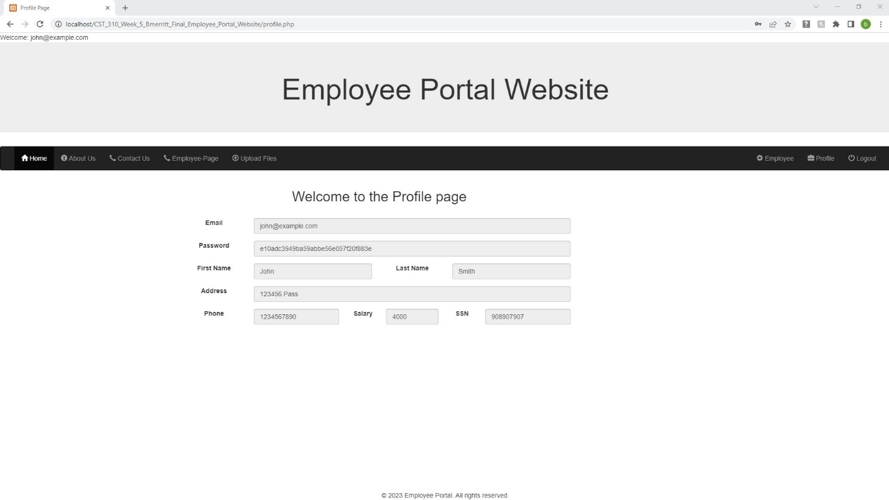

Figure . Logged in John.

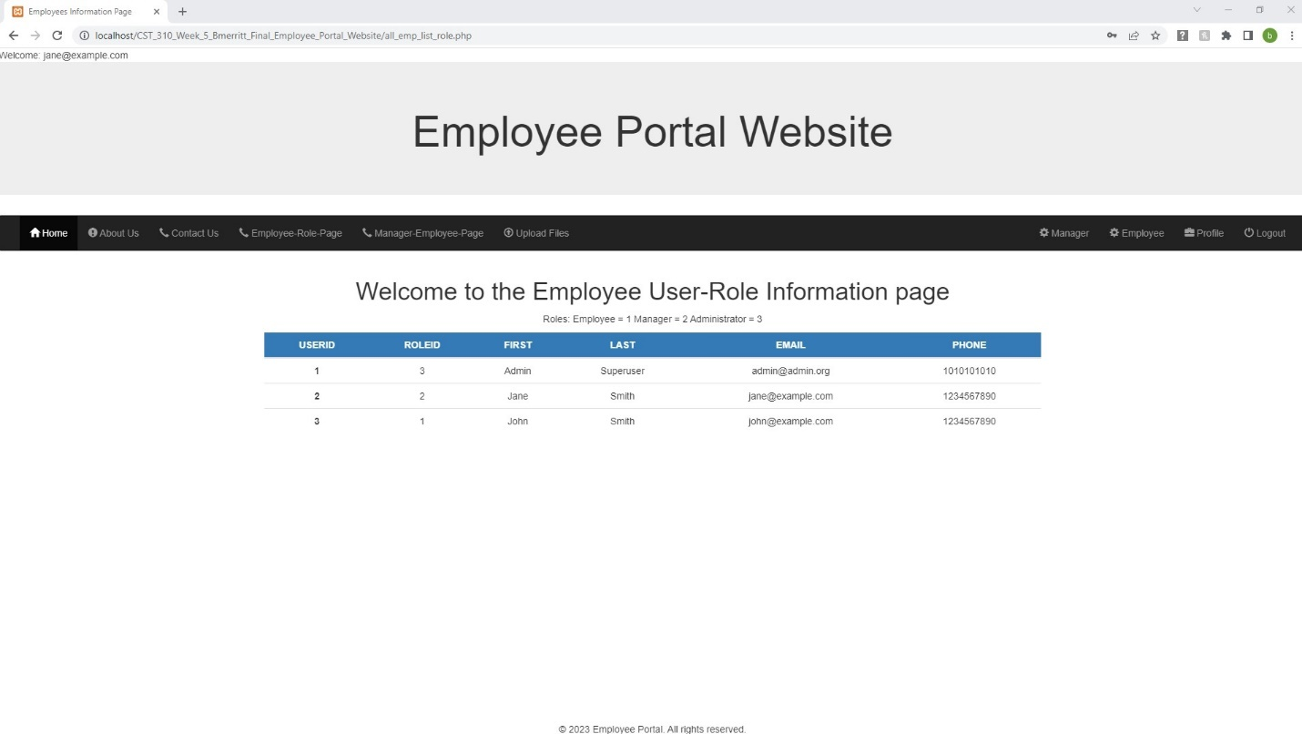

Figure . Logged in Jane. John is user 3 role 1

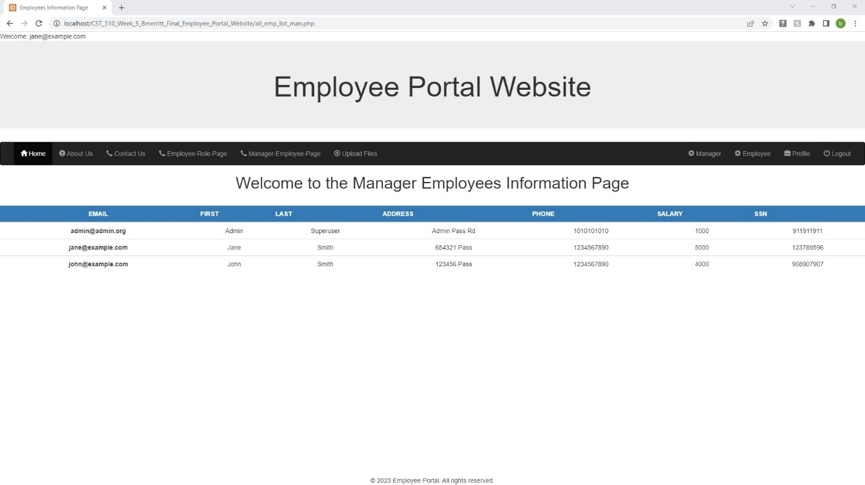

Figure . Jane sees Johns last name Smith and salary 4000

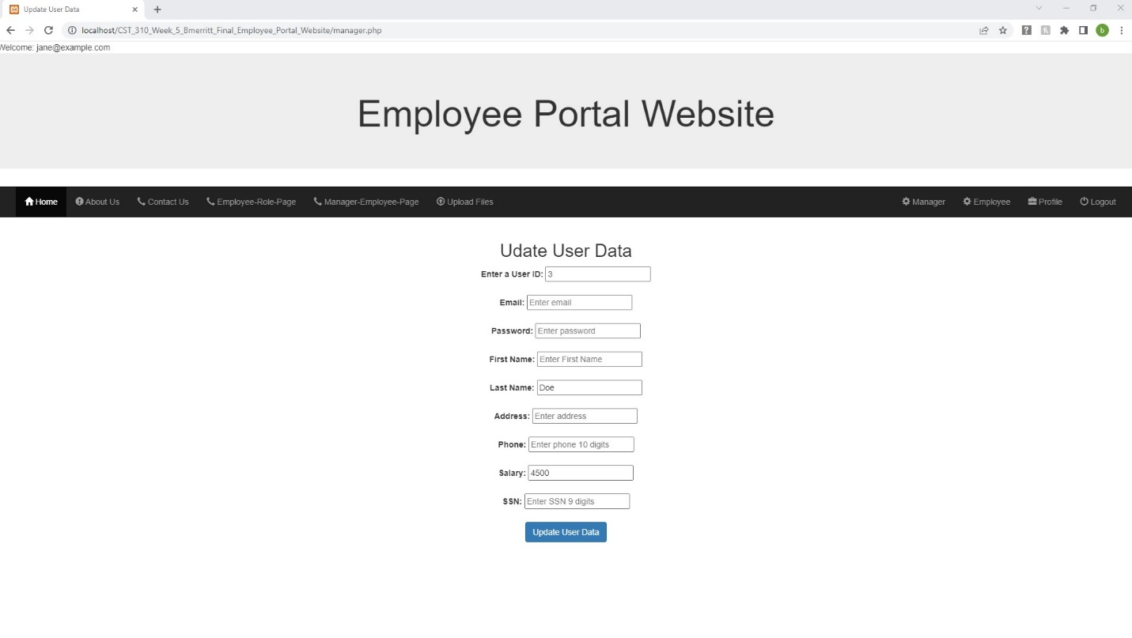

Figure . Jane updates Johns Last name Doe and salary to 4500.

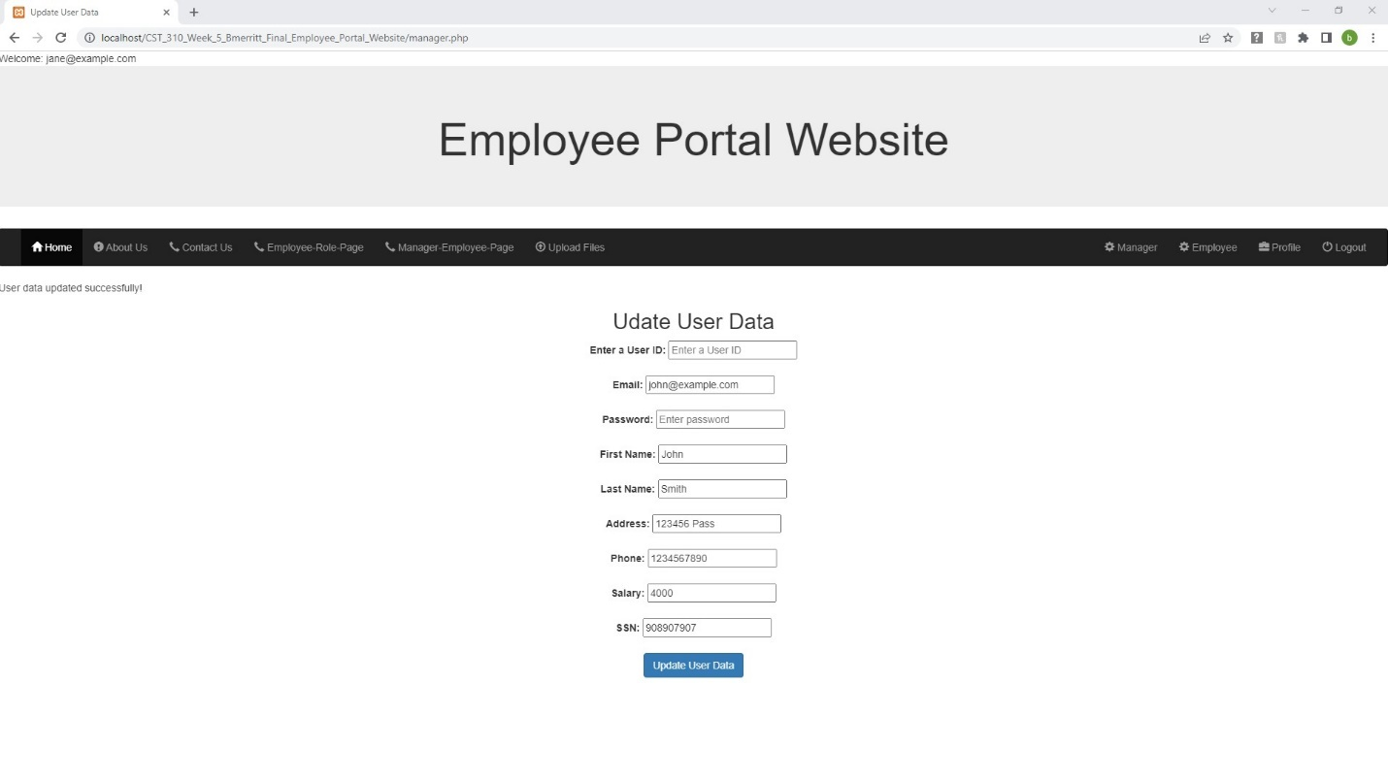

Figure . Jane is successful changing Johns information.

Figure . Data shows in Manager Employees Page.

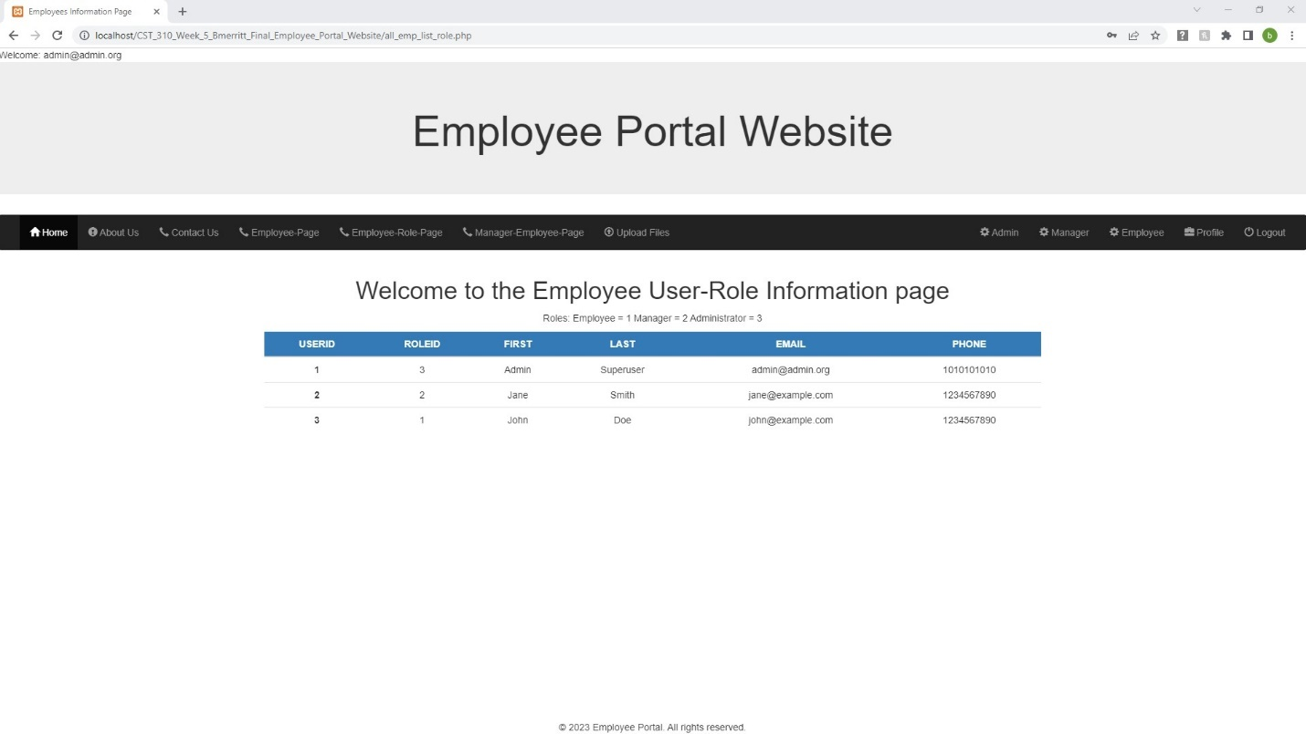

Figure . Admin Login John is user 3 role 1.

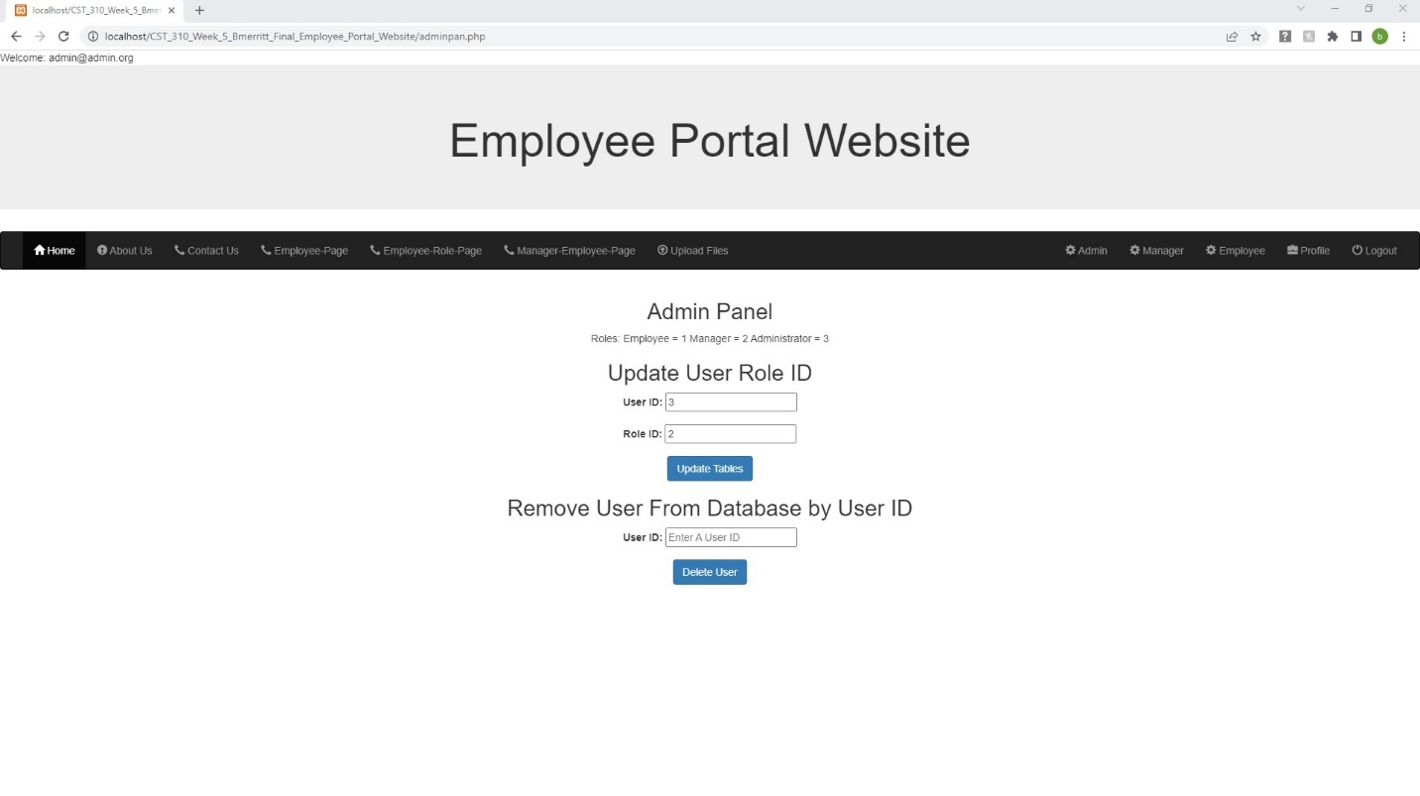

Figure . John is upgraded to Manager.

Figure . Employee User-Role page shows Updated information.

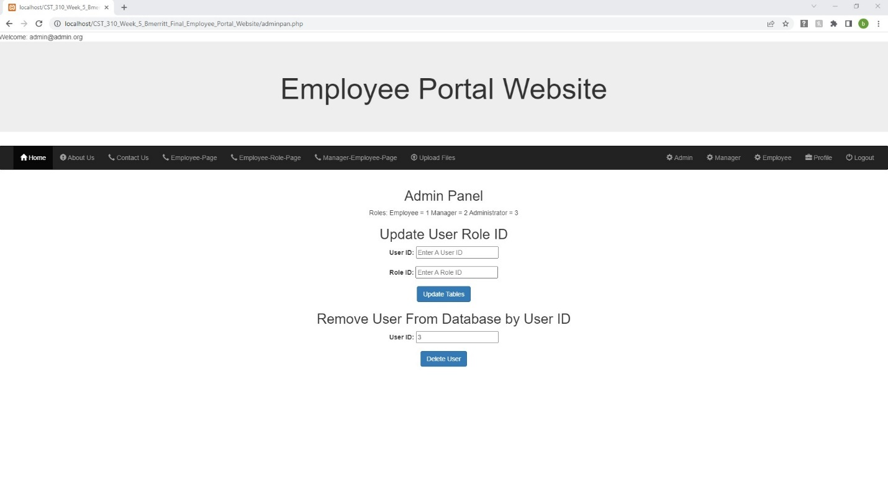

Figure . Admin Panel User 3 John entered for Removal.

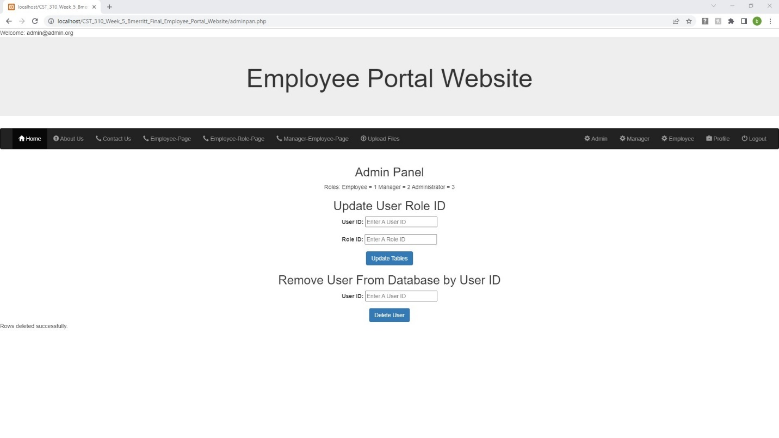

Figure . John was removed from database.

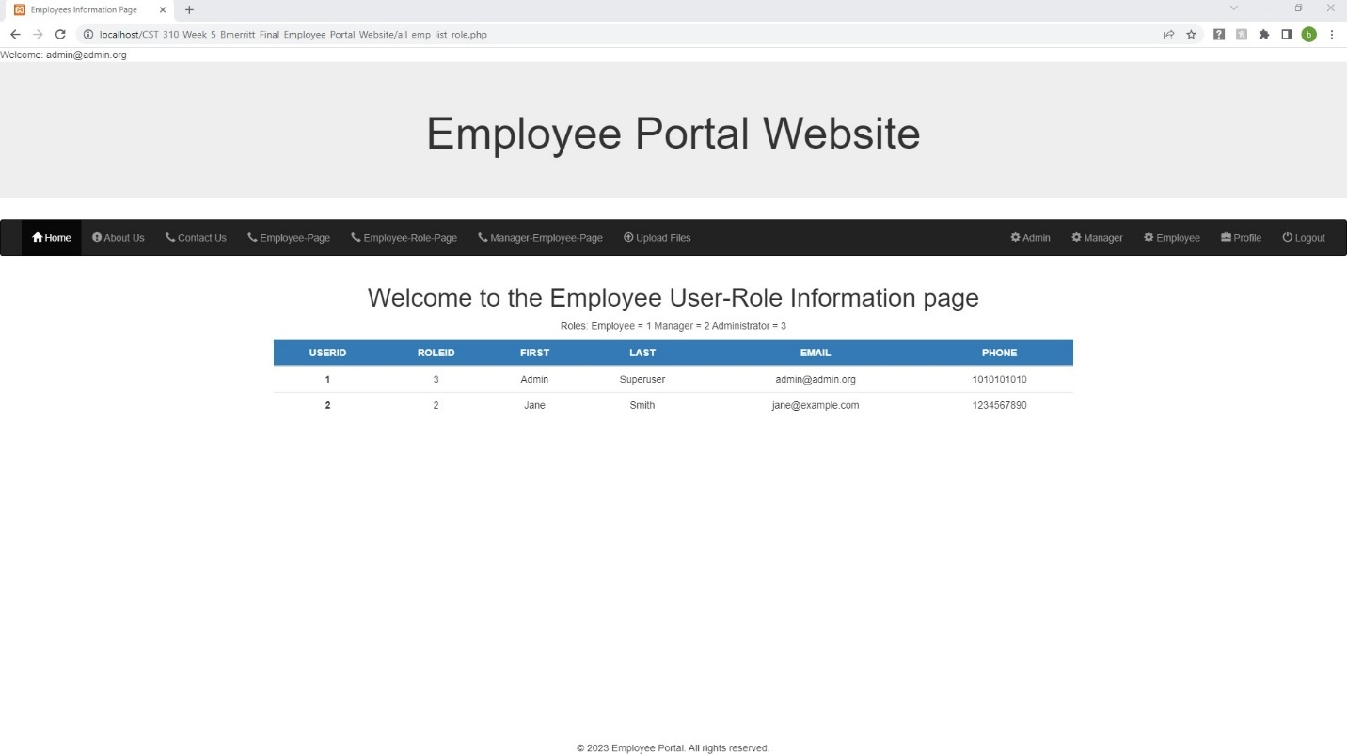

Figure . John is removed from employee role page.

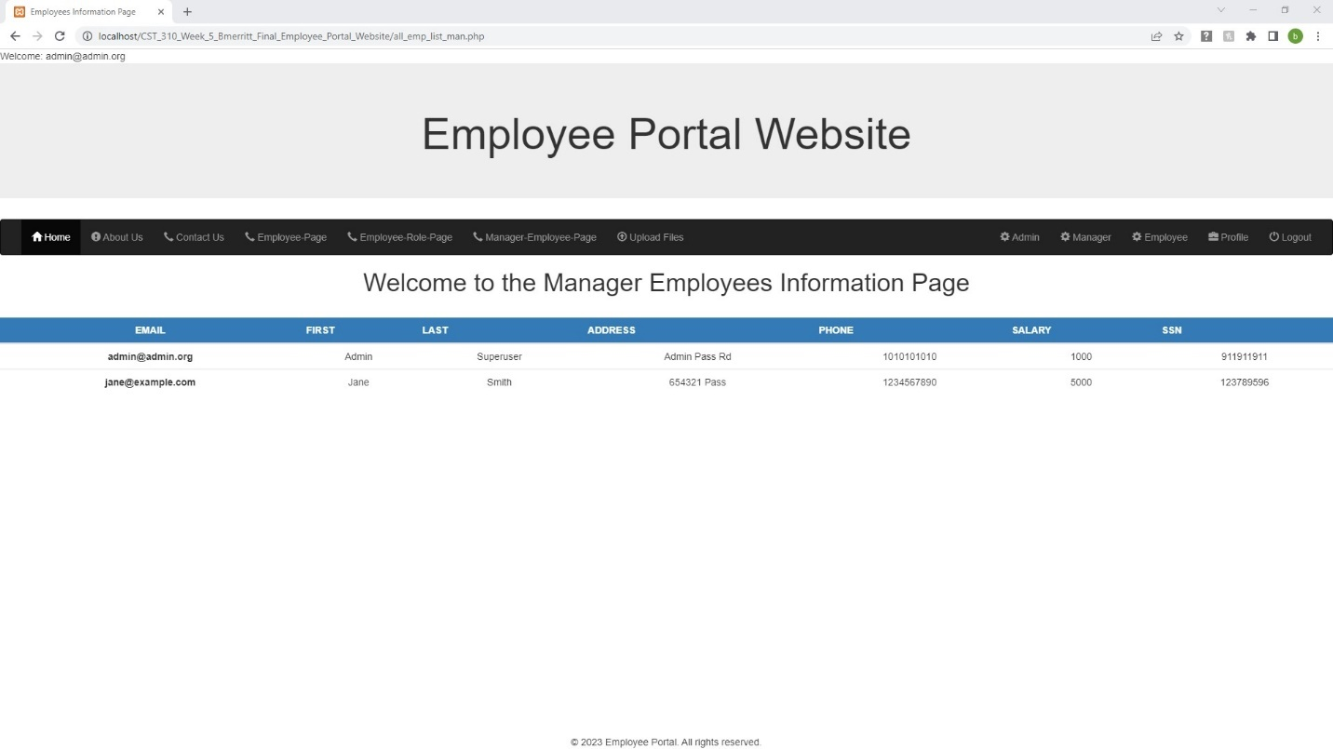

Figure . John removed from Manager Page.

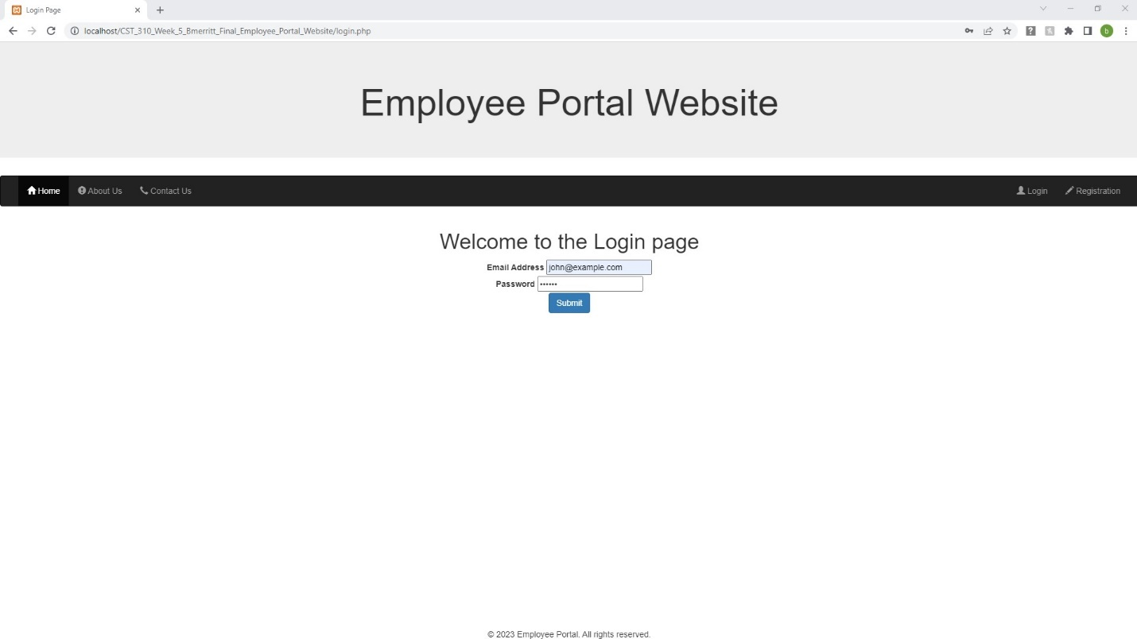

Figure . John trys login.

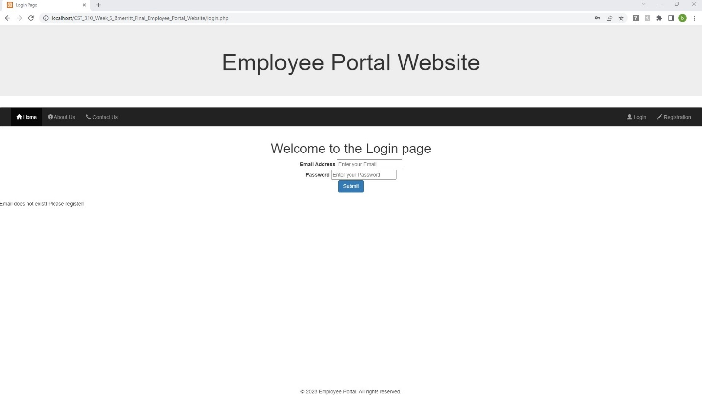

Figure . Login fails.

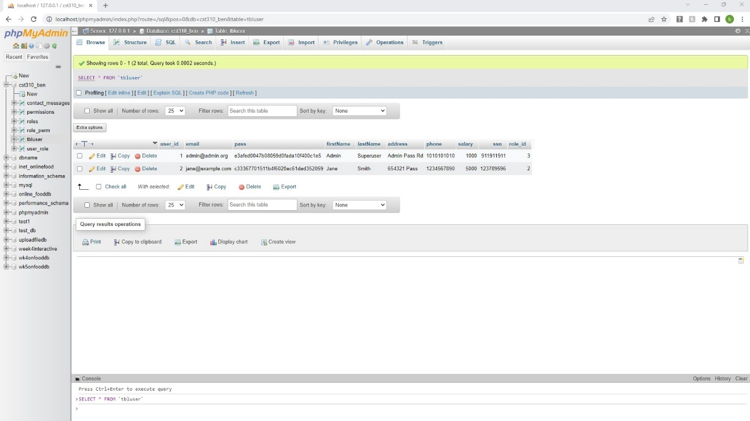

Figure . John is removed from database.

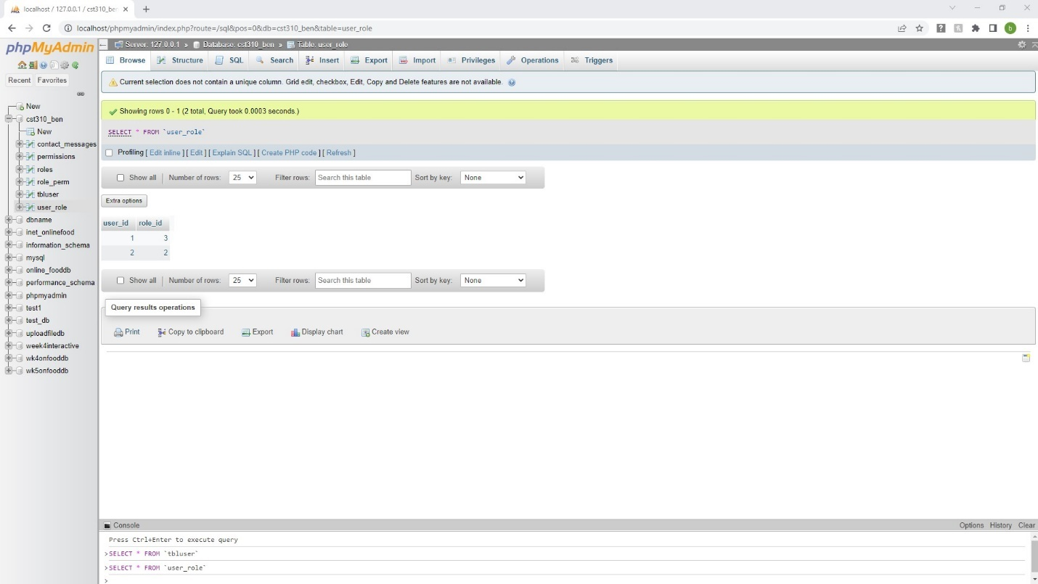

Figure . John is removed from user_role table also.

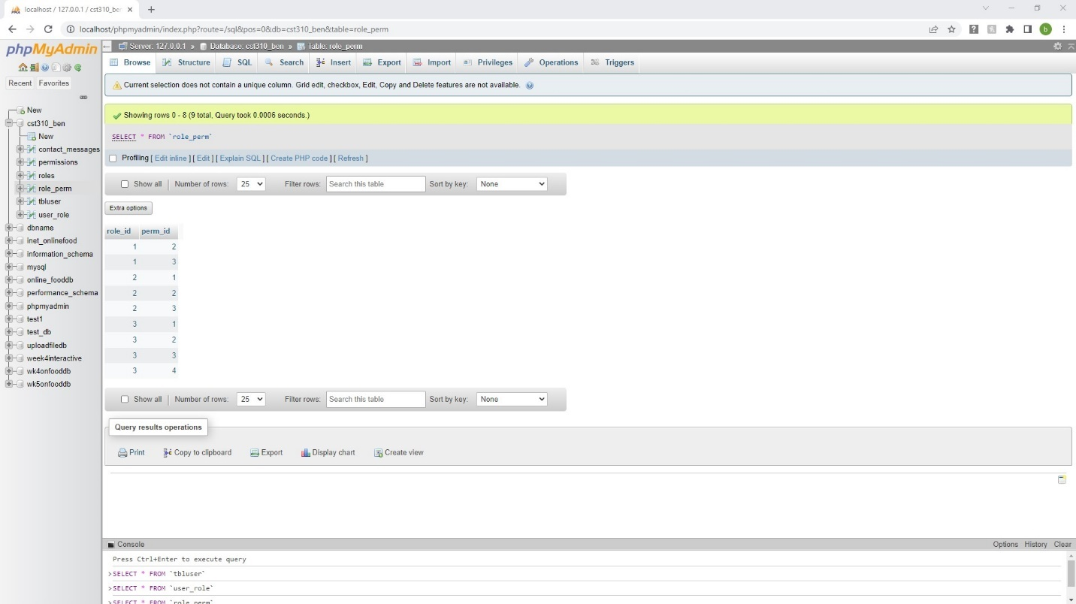

Figure . User role permissions.

Figure . User Roles.

Figure . Permissions create, read, update, delete.

**Explain the steps taken to create the Employee Portal Website.**

The initial step was to create the database “cst310_ben” and tables using phpMyAdmin and importing a SQL script with Admin user inserted. A trigger in the database auto updated the user_role table. The second step was to create a user through the registration.php page default user role is 1 for employee. The third step was to log in with the login.php page. A SESSION ‘username’ is created, and then the master.php code removes Login and Registration and shows Profile and Logout in the top right of the page Profile page is auto loaded. Welcome to the Employee Home page ‘Name’ is displayed if the Home tab is clicked, user stays logged in.

Password and invalid Email checking errors are included to check the format and against the database for security. I added the roles, different access, view or update to employee information pages. The employee portal website was very challenging and I learned there are many ways to design a website. I changed my connection code to PDO and it was difficult to understand at first, but I feel more confident after creating this project. The employee portal website is used in many businesses and is used to manage employee information. Please refer to the pictures above for a detailed description of the functions of the employee portal website.

Connolly & Hoar (2018) and Github.com showed examples of code and commands to help create the employee portal website.

Script is many .php files inside package.

Here is the link to the Screencast video URL: <https://screenpal.com/watch/c0h01xVAgnB>

Here is the Folio project link: https://portfolium.com/entry/cst-310-employee-portal-website-final-project.

**Conclusion**

Creating many pages and retrieving and verifying user information in a database is integral to building a website with user authentication. The steps are taken in this paper, such as creating the database and table, registering a user, logging in, retrieving the data, verification of the data, displaying profile layout and data for authorized employees, and logging out, can help in designing an employee portal website.

Reference

Connolly, R., & Hoar, R. (2018). [*Fundamentals of web development*](https://uagc.instructure.com/courses/116471/modules/items/5922958) (2nd ed.). Pearson.

Github.com (n.d). Search results for employee portal examples.